PH 201 Homework Assignment Chapter on
Work & Energy – 34 Problems Total
1. You are moving into an apartment and take the elevator to the 6th floor. Suppose your weight is 685 N and that of your belongings is 915 N. (a) Determine the work done by the elevator in lifting you and your belongings up to the 6th floor (15.2 m) at a constant velocity. (b) How much work does the elevator do on you alone (without belongings) on the downward trip, which is also made at a constant velocity?
Solution for Problem 1
2. A 75.0-kg man is riding an escalator in a shopping mall. The escalator moves the man at a constant velocity from ground level to the floor above, a vertical height of 4.60 m. What is the work done on the man by (a) the gravitational force and (b) the escalator?
Solution for Problem 2
3. A person pushes a 16.0-kg shopping cart at a constant velocity for a distance of 22.0 m. She pushes in a direction 29.0° below the horizontal. A 48.0-N frictional force opposes the motion of the cart. (a) What is the magnitude of the force that the shopper exerts? Determine the work done by (b) the pushing force, (c) the frictional force, and (d) the gravitational force.
Solution for Problem 3
4. The drawing shows a plane diving toward the ground and then climbing back upward. During each of these motions, the lift force $\vec{L}$ acts perpendicular to the displacement $\vec{S}$, which has the same magnitude, 1.7 x 103 m, in each case. The engines of the plane exert a thrust $\vec{T}$, which points in the direction of the displacement and has the same magnitude during the dive and the climb. The weight $\vec{W}$ of the plane has a magnitude of 5.9 x 104 N. In both motions, net work is performed due to the combined action of the forces $\vec{L}$, $\vec{T}$, and $\vec{W}$. (a) Is more net work done during the dive or the climb? Explain. (b) Find the difference between the net work done during the dive and the climb.
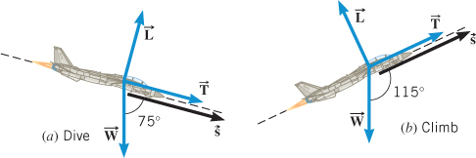
Solution for Problem 4
5. A person pulls a toboggan for a distance of 35.0 m along the snow with a rope directed 25.0° above the snow. The tension in the rope is 94.0 N. (a) How much work is done on the toboggan by the tension force? (b) How much work is done if the same tension is directed parallel to the snow?
Solution for Problem 5
6. A 1.00 x 102-kg crate is being pushed across a horizontal floor by a force $\vec{p}$ that makes an angle of 30.0° below the horizontal. The coefficient of kinetic friction is 0.200. What should be the magnitude of $\vec{p}$, so that the net work done by it and the kinetic frictional force is zero?
Solution for Problem 6
7. A 1200-kg car is being driven up a 5.0° hill. The frictional force is directed opposite to the motion of the car and has a magnitude of f = 524 N. A force $\vec{F}$ is applied to the car by the road and propels the car forward. In addition to these two forces, two other forces act on the car: its weight $\vec{W}$ and the normal force $\vec{F_{N}}$ directed perpendicular to the road surface. The length of the road up the hill is 290 m. What should be the magnitude of $\vec{F}$, so that the net work done by all the forces acting on the car is + 150 kJ?
Solution for Problem 7
8. A fighter jet is launched from an aircraft carrier with the aid of its own engines and a steam-powered catapult. The thrust of its engines is 2.3 x 105 N. In being launched from rest it moves through a distance of 87 m and has a kinetic energy of 4.5 x 107 J at lift-off. What is the work done on the jet by the catapult?
Solution for Problem 8
9. It takes 185 kJ of work to accelerate a car from 23.0 m/s to 28.0 m/s. What is the car’s mass?
Solution for Problem 9
10. A 7420-kg satellite has an elliptical orbit, as in the (b) figure below. The point on the orbit that is farthest from the earth is called the apogee and is at the far right side of the drawing. The point on the orbit that is closest to the earth is called the perigee and is at the left side of the drawing. Suppose that the speed of the satellite is 2820 m/s at the apogee and 8450 m/s at the perigee. Find the work done by the gravitational force when the satellite moves from (a) the apogee to the perigee and (b) the perigee to the apogee.
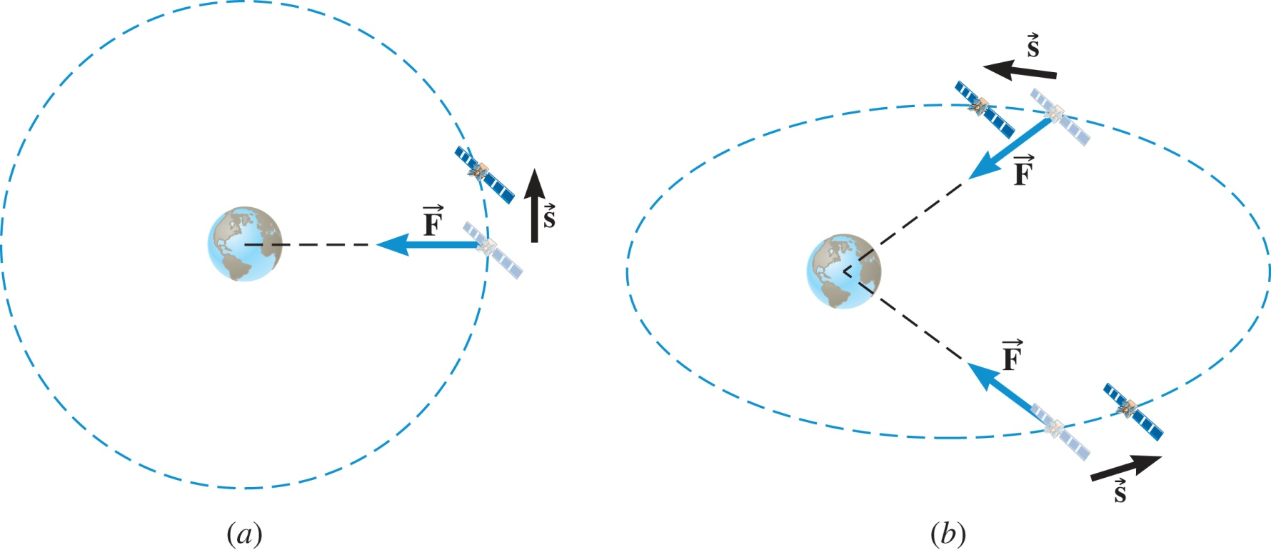
Solution for Problem 10
11. A 16-kg sled is being pulled along the horizontal snow-covered ground by a horizontal force of 24 N. Starting from rest, the sled attains a speed of 2.0 m/s in 8.0 m. Find the coefficient of kinetic friction between the runners of the sled and the snow.
Solution for Problem 11
12. A rescue helicopter lifts a 79-kg person straight up by means of a cable. The person has an upward acceleration of 0.70 m/s2 and is lifted from rest through a distance of 11 m.
(a) What is the tension in the cable? How much work is done by (b) the tension in the cable and (c) the person’s weight? (d) Use the work–energy theorem and find the final speed of the person.
Solution for Problem 12
13. A 6200-kg satellite is in a circular earth orbit that has a radius of 3.3 x 107 m. A net external force must act on the satellite to make it change to a circular orbit that has a radius of 7.0 x 106 m. What work W must the net external force do? Note that the work determined here is not the work Wlift done by the satellite’s engines to change the orbit. Instead, the work W is W = Wlift + Wgravitational, where Wgravitational is the work done by the gravitational force.
Solution for Problem 13
14. Under the influence of its drive force, a snowmobile is moving at a constant velocity along a horizontal patch of snow. When the drive force is shut off, the snowmobile coasts to a halt. The snowmobile and its rider have a mass of 136 kg. Under the influence of a drive force of 205 N, it is moving at a constant velocity whose magnitude is 5.50 m/s. The drive force is then shut off. Find (a) the distance in which the snowmobile coasts to a halt and (b) the time required to do so.
Solution for Problem 14
15. The model airplane in Figure 5.6 is flying at a speed of 22 m/s on a horizontal circle of radius 16 m. The mass of the plane is 0.90 kg. The person holding the guideline pulls it in until the radius becomes 14 m. The plane speeds up, and the tension in the guideline becomes four times greater. What is the net work done on the plane?
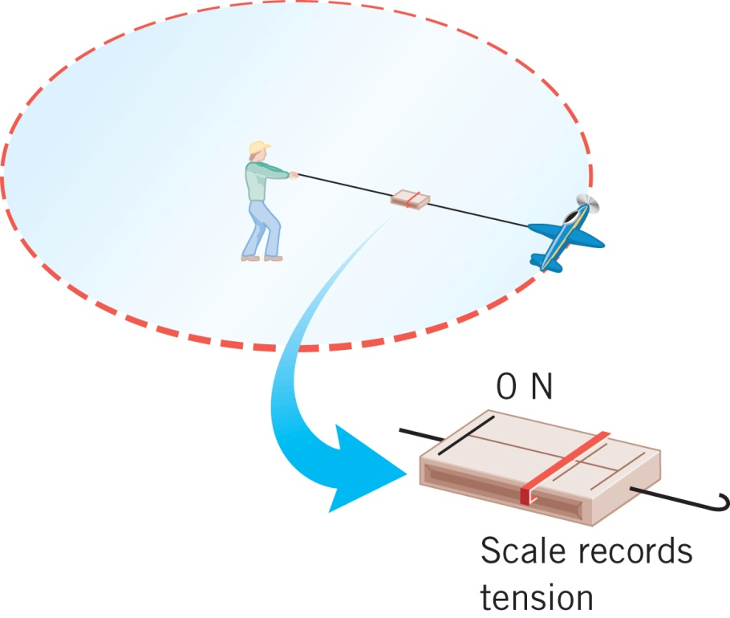
Solution for Problem 15
16. A 75.0-kg skier rides a 2830-m-long lift to the top of a mountain. The lift makes an angle of 14.6° with the horizontal. What is the change in the skier’s gravitational potential energy?
Solution for Problem 16
17. A 0.60-kg basketball is dropped out of a window that is 6.1 m above the ground. The ball is caught by a person whose hands are 1.5 m above the ground. (a) How much work is done on the ball by its weight? What is the gravitational potential energy of the basketball, relative to the ground, when it is (b) released and (c) caught? (d) How is the change (PEf - PE0) in the ball’s gravitational potential energy related to the work done by its weight?
Solution for Problem 17
18. A 35-kg girl is bouncing on a trampoline. During a certain interval after she leaves the surface of the trampoline, her kinetic energy decreases to 210 J from 440 J. How high does she rise during this interval? Neglect air resistance.
Solution for Problem 18
19. The skateboarder in the drawing starts down the left side of the ramp with an initial speed of 5.4 m/s. Neglect nonconservative forces, such as friction and air resistance, and find the height h of the highest point reached by the skateboarder on the right side of the ramp.
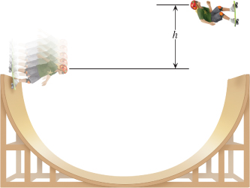
Solution for Problem 19
20. The drawing shows two boxes resting on frictionless ramps. One box is relatively light and sits on a steep ramp. The other box is heavier and rests on a ramp that is less steep. The boxes are released from rest at A and allowed to slide down the ramps. The two boxes have masses of 11 and 44 kg. If A and B are 4.5 and 1.5 m, respectively, above the ground, determine the speed of (a) the lighter box and (b) the heavier box when each reaches B. (c) What is the ratio of the kinetic energy of the heavier box to that of the lighter box at B?
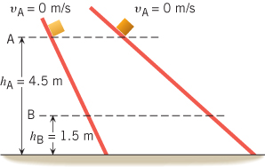
Solution for Problem 20
21. The drawing shows a skateboarder moving at 5.4 m/s along a horizontal section of a track that is slanted upward by 48° above the horizontal at its end, which is 0.40 m above the ground. When she leaves the track, she follows the characteristic path of projectile motion. Ignoring friction and air resistance, find the maximum height H to which she rises above the end of the track.
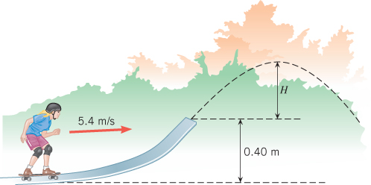
Solution for Problem 21
22. A skier starts from rest at the top of a hill. The skier coasts down the hill and up a second hill, as the drawing illustrates. The crest of the second hill is circular, with a radius of
r = 36 m. Neglect friction and air resistance. What must be the height h of the first hill so that the skier just loses contact with the snow at the crest of the second hill?
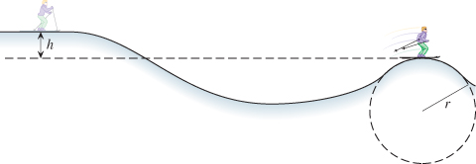
Solution for Problem 22
23. A person starts from rest at the top of a large frictionless spherical surface, and slides into the water below (see the drawing). At what angle θ does the person leave the surface? (Hint: When the person leaves the surface, the normal force is zero.)
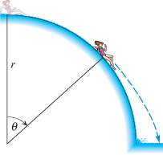
Solution for Problem 23
24. Starting from rest, a 93-kg firefighter slides down a fire pole. The average frictional force exerted on him by the pole has a magnitude of 810 N, and his speed at the bottom of the pole is 3.4 m/s. How far did he slide down the pole?
Solution for Problem 24
25. In the sport of skeleton a participant jumps onto a sled (known as a skeleton) and proceeds to slide down an icy track, belly down and head first. In the 2010 Winter Olympics, the track had sixteen turns and dropped 126 m in elevation from top to bottom. (a) In the absence of nonconservative forces, such as friction and air resistance, what would be the speed of a rider at the bottom of the track? Assume that the speed at the beginning of the run is relatively small and can be ignored. (b) In reality, the gold-medal winner (Canadian Jon Montgomery) reached the bottom in one heat with a speed of 40.5 m/s (about 91 mi/h). How much work was done on him and his sled (assuming a total mass of 118 kg) by nonconservative forces during this heat?
Solution for Problem 25
26. In attempting to pass the puck to a teammate, a hockey player gives it an initial speed of 1.7 m/s. However, this speed is inadequate to compensate for the kinetic friction between the puck and the ice. As a result, the puck travels only one-half the distance between the players before sliding to a halt. What minimum initial speed should the puck have been given so that it reached the teammate, assuming that the same force of kinetic friction acted on the puck everywhere between the two players?
Solution for Problem 26
27. A pitcher throws a 0.140-kg baseball, and it approaches the bat at a speed of 40.0 m/s. The bat does Wnc = 70.0 J of work on the ball in hitting it. Ignoring air resistance, determine the speed of the ball after the ball leaves the bat and is 25.0 m above the point of impact.
Solution for Problem 27
28. At a carnival, you can try to ring a bell by striking a target with a 9.00-kg hammer. In response, a 0.400-kg metal piece is sent upward toward the bell, which is 5.00 m above. Suppose that 25.0% of the hammer’s kinetic energy is used to do the work of sending the metal piece upward. How fast must the hammer be moving when it strikes the target so that the bell just barely rings?
Solution for Problem 28
29. A truck is traveling at 11.1 m/s down a hill when the brakes on all four wheels lock. The hill makes an angle of 15.0° with respect to the horizontal. The coefficient of kinetic friction between the tires and the road is 0.750. How far does the truck skid before coming to a stop?
Solution for Problem 29
30. Bicyclists in the Tour de France do enormous amounts of work during a race. For example, the average power per kilogram generated by seven-time-winner Lance Armstrong
(m = 75.0 kg) is 6.50 W per kilogram of his body mass. (a) How much work does he do during a 135-km race in which his average speed is 12.0 m/s? (b) Often, the work done is expressed in nutritional Calories rather than in joules. Express the work done in part (a) in terms of nutritional Calories, noting that 1 joule = 2.389 x 10-4 nutritional Calories.
Solution for Problem 30
31. You are working out on a rowing machine. Each time you pull the rowing bar (which simulates the oars) toward you, it moves a distance of 1.2 m in a time of 1.5 s. The readout on the display indicates that the average power you are producing is 82 W. What is the magnitude of the force that you exert on the handle?
Solution for Problem 31
32. The motor of a ski boat generates an average power of 7.50 x 104 W when the boat is moving at a constant speed of 12 m/s. When the boat is pulling a skier at the same speed, the engine must generate an average power of 8.30 x 104 W. What is the tension in the tow rope that is pulling the skier?
Solution for Problem 32
33. A 1900-kg car experiences a combined force of air resistance and friction that has the same magnitude whether the car goes up or down a hill at 27 m/s. Going up a hill, the car’s engine produces 47 hp more power to sustain the constant velocity than it does going down the same hill. At what angle is the hill inclined above the horizontal?
Solution for Problem 33
34. “Rocket Man” has a propulsion unit strapped to his back. He starts from rest on the ground, fires the unit, and accelerates straight upward. At a height of 16 m, his speed is
5.0 m/s. His mass, including the propulsion unit, has the approximately constant value of
136 kg. Find the work done by the force generated by the propulsion unit.
Solution for Problem 34
 | Dr. Donovan's Classes Page |  | Dr. Donovan's PH 201 Homework Page
 | NMU Physics Department Web Page |  | NMU Main Page

Please send any comments or questions about this page to ddonovan@nmu.edu
This page last updated on November 13, 2021

