PH 201 Homework Assignment Chapter on
Impulse & Momentum – 25 Problems Total
1. A 46-kg skater is standing still in front of a wall. By pushing against the wall she propels herself backward with a velocity of -1.2 m/s. Her hands are in contact with the wall for 0.80 s. Ignore friction and wind resistance. Find the magnitude and direction of the average force she exerts on the wall (which has the same magnitude as, but opposite direction to, the force that the wall applies to her).
Solution for Problem 1
2. A model rocket is constructed with a motor that can provide a total impulse of 29.0 N s. The mass of the rocket is 0.175 kg. What is the speed that this rocket achieves when launched from rest? Neglect the effects of gravity and air resistance.
Solution for Problem 2
3. In a performance test, each of two cars takes 9.0 s to accelerate from rest to 27 m/s. Car A has a mass of 1400 kg, and car B has a mass of 1900 kg. Find the net average force that acts on each car during the test.
Solution for Problem 3
4. A volleyball is spiked so that its incoming velocity of +4.0 m/s is changed to an outgoing velocity of -21 m/s. The mass of the volleyball is 0.35 kg. What impulse does the player apply to the ball?
Solution for Problem 4
5. When jumping straight down, you can be seriously injured if you land stiff-legged. One way to avoid injury is to bend your knees upon landing to reduce the force of the impact. A 75-kg man just before contact with the ground has a speed of 6.4 m/s. (a) In a stiff-legged landing he comes to a halt in 2.0 ms. Find the average net force that acts on him during this time. (b) When he bends his knees, he comes to a halt in 0.10 s. Find the average net force now. (c) During the landing, the force of the ground on the man points upward, while the force due to gravity points downward. The average net force acting on the man includes both of these forces. Taking into account the directions of the forces, find the force of the ground on the man in parts (a) and (b).
Solution for Problem 5
6. A space probe is traveling in outer space with a momentum that has a magnitude of
7.5 x 107 kg m/s. A retrorocket is fired to slow down the probe. It applies a force to the probe that has a magnitude of 2.0 x 106 N and a direction opposite to the probe’s motion. It fires for a period of 12 s. Determine the momentum of the probe after the retrorocket ceases to fire.
Solution for Problem 6
7. A student (m = 63 kg) falls freely from rest and strikes the ground. During the collision with the ground, he comes to rest in a time of 0.040 s. The average force exerted on him by the ground is +18 000 N, where the upward direction is taken to be the positive direction. From what height did the student fall? Assume that the only force acting on him during the collision is that due to the ground.
Solution for Problem 7
8. A golf ball strikes a hard, smooth floor at an angle of 30.0° and, as the drawing shows, rebounds at the same angle. The mass of the ball is 0.047 kg, and its speed is 45 m/s just before and after striking the floor. What is the magnitude of the impulse applied to the golf ball by the floor? (Hint: Note that only the vertical component of the ball’s momentum changes during impact with the floor, and ignore the weight of the ball.)
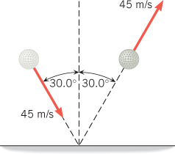
Solution for Problem 8
9. A dump truck is being filled with sand. The sand falls straight downward from rest from a height of 2.00 m above the truck bed, and the mass of sand that hits the truck per second is 55.0 kg/s. The truck is parked on the platform of a weight scale. By how much does the scale reading exceed the weight of the truck and sand?
Solution for Problem 9
10. A lumberjack (mass = 98 kg) is standing at rest on one end of a floating log
(mass = 230 kg) that is also at rest. The lumberjack runs to the other end of the log, attaining a velocity of +3.6 m/s relative to the shore, and then hops onto an identical floating log that is initially at rest. Neglect any friction and resistance between the logs and the water. (a) What is the velocity of the first log just before the lumberjack jumps off? (b) Determine the velocity of the second log if the lumberjack comes to rest on it.
Solution for Problem 10
11. A two-stage rocket moves in space at a constant velocity of 4900 m/s. The two stages are then separated by a small explosive charge placed between them. Immediately after the explosion the velocity of the 1200-kg upper stage is 5700 m/s in the same direction as before the explosion. What is the velocity (magnitude and direction) of the 2400-kg lower stage after the explosion?
Solution for Problem 11
12. A 40.0-kg boy, riding a 2.50-kg skateboard at a velocity of +5.30 m/s across a level sidewalk, jumps forward to leap over a wall. Just after leaving contact with the board, the boy’s velocity relative to the sidewalk is 6.00 m/s, 9.50° above the horizontal. Ignore any friction between the skateboard and the sidewalk. What is the skateboard’s velocity relative to the sidewalk at this instant? Be sure to include the correct algebraic sign with your answer.
Solution for Problem 12
13. The lead female character in the movie Diamonds Are Forever is standing at the edge of an offshore oil rig. As she fires a gun, she is driven back over the edge and into the sea. Suppose the mass of a bullet is 0.010 kg and its velocity is +720 m/s. Her mass (including the gun) is 51 kg. (a) What recoil velocity does she acquire in response to a single shot from a stationary position, assuming that no external force keeps her in place? (b) Under the same assumption, what would be her recoil velocity if, instead, she shoots a blank cartridge that ejects a mass of 5.0 x 10-4 kg at a velocity of +720 m/s?
Solution for Problem 13
14. By accident, a large plate is dropped and breaks into three pieces. The pieces fly apart parallel to the floor. As the plate falls, its momentum has only a vertical component and no component parallel to the floor. After the collision, the component of the total momentum parallel to the floor must remain zero, since the net external force acting on the plate has no component parallel to the floor. Using the data shown in the drawing, find the masses of pieces 1 and 2.
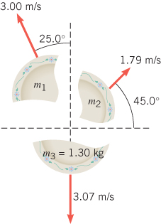
Solution for Problem 14
15. A cannon of mass 5.80 x 103 kg is rigidly bolted to the earth so it can recoil only by a negligible amount. The cannon fires an 85.0-kg shell horizontally with an initial velocity of +551 m/s. Suppose the cannon is then unbolted from the earth, and no external force hinders its recoil. What would be the velocity of an identical shell fired by this loose cannon? (Hint: In both cases assume that the burning gunpowder imparts the same kinetic energy to the system.)
Solution for Problem 15
16. One object is at rest, and another is moving. The two collide in a one-dimensional, completely inelastic collision. In other words, they stick together after the collision and move off with a common velocity. Momentum is conserved. The speed of the object that is moving initially is 25 m/s. The masses of the two objects are 3.0 and 8.0 kg. Determine the final speed of the two-object system after the collision for the case when the large-mass object is the one moving initially and the case when the small-mass object is the one moving initially.
Solution for Problem 16
17. One object is at rest, and another is moving. The two collide in a one-dimensional, completely inelastic collision. In other words, they stick together after the collision and move off with a common velocity. Momentum is conserved. The speed of the object that is moving initially is 25 m/s. The masses of the two objects are 3.0 and 8.0 kg. Determine the final speed of the two-object system after the collision for the case when the large-mass object is the one moving initially and the case when the small-mass object is the one moving initially.
Solution for Problem 17
18. A car (mass = 1100 kg) is traveling at 32 m/s when it collides head-on with a sport utility vehicle (mass = 2500 kg) traveling in the opposite direction. In the collision, the two vehicles come to a halt. At what speed was the sport utility vehicle traveling?
Solution for Problem 18
19. A 5.00-kg ball, moving to the right at a velocity of +2.00 m/s on a frictionless table, collides head-on with a stationary 7.50-kg ball. Find the final velocities of the balls if the collision is (a) elastic and (b) completely inelastic.
Solution for Problem 19
20. The drawing shows a collision between two pucks on an air-hockey table. Puck A has a mass of 0.025 kg and is moving along the x axis with a velocity of +5.5 m/s. It makes a collision with puck B, which has a mass of 0.050 kg and is initially at rest. The collision is not head-on. After the collision, the two pucks fly apart with the angles shown in the drawing. Find the final speeds of (a) puck A and (b) puck B.
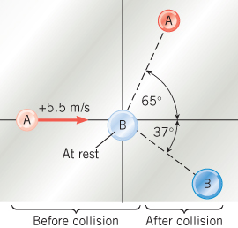
Solution for Problem 20
21. A ball is attached to one end of a wire, the other end being fastened to the ceiling. The wire is held horizontal, and the ball is released from rest (see the drawing). It swings downward and strikes a block initially at rest on a horizontal frictionless surface. Air resistance is negligible, and the collision is elastic. The masses of the ball and block are, respectively, 1.60 kg and 2.40 kg, and the length of the wire is 1.20 m. Find the velocity (magnitude and direction) of the ball (a) just before the collision, and (b) just after the collision.
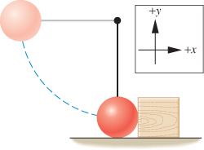
Solution for Problem 21
22. A girl is skipping stones across a lake. One of the stones accidentally ricochets off a toy boat that is initially at rest in the water (see the drawing). The 0.072-kg stone strikes the boat at a velocity of 13 m/s, 15° below due east, and ricochets off at a velocity of 11 m/s,
12° above due east. After being struck by the stone, the boat’s velocity is 2.1 m/s, due east. What is the mass of the boat? Assume the water offers no resistance to the boat’s motion.
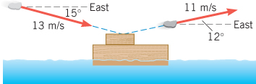
Solution for Problem 22
23. An electron collides elastically with a stationary hydrogen atom. The mass of the hydrogen atom is 1837 times that of the electron. Assume that all motion, before and after the collision, occurs along the same straight line. What is the ratio of the kinetic energy of the hydrogen atom after the collision to that of the electron before the collision?
Solution for Problem 23
24. Two stars in a binary system orbit around their center of mass. The centers of the two stars are 7.17 x 10¹¹ m apart. The larger of the two stars has a mass of 3.70 x 10³⁰ kg, and its center is 2.08 x 10¹¹ m from the system’s center of mass. What is the mass of the smaller star?
Solution for Problem 24
25. The drawing shows a sulfur dioxide molecule. It consists of two ­oxygen atoms and a sulfur atom. A sulfur atom is twice as massive as an oxygen atom. Using this information and the data provided in the drawing, find (a) the x coordinate and (b) the y coordinate of the center of mass of the sulfur dioxide molecule. Express your answers in nanometers
(1 nm x 10-9 m).
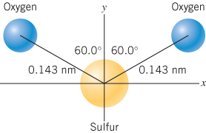
Solution for Problem 25
 | Dr. Donovan's Classes Page |  | Dr. Donovan's PH 201 Homework Page
 | NMU Physics Department Web Page |  | NMU Main Page

Please send any comments or questions about this page to ddonovan@nmu.edu
This page last updated on November 18, 2021

