PH 201 Homework Assignment Chapter on Vectors and Introductory Math Concepts – 21 Problems Total
1. A student sees a newspaper ad for an apartment that has 1330 square feet (ft²) of floor space. How many square meters of area are there?
Solution for Problem 1
2. Suppose a man’s scalp hair grows at a rate of 0.35 mm per day. What is this growth rate in feet per century?
Solution for Problem 2
3. A bottle of wine known as a magnum contains a volume of 1.5 liters. A bottle known as a jeroboam contains 0.792 U.S. gallons. How many magnums are there in one jeroboam?
Solution for Problem 3
4. A partly full paint can has 0.67 U.S. gallons of paint left in it. (a) What is the volume of the paint in cubic meters? (b) If all the remaining paint is used to coat a wall evenly (wall area = 13 m²), how thick is the layer of wet paint? Give your answer in meters.
Solution for Problem 4
5. A spring is hanging down from the ceiling, and an object of mass m is attached to the free end. The object is pulled down, thereby stretching the spring, and then released. The object oscillates up and down, and the time T required for one complete up-and-down oscillation is given by the equation $T=2π\sqrt{m/k}$, where k is known as the spring constant. What must be the dimension of k for this equation to be dimensionally correct?
Solution for Problem 5
6. You are driving into St. Louis, Missouri, and in the distance you see the famous Gateway to the West arch. This monument rises to a height of 192 m. You estimate your line of sight with the top of the arch to be 2.0° above the horizontal. Approximately how far (in kilometers) are you from the base of the arch?
Solution for Problem 6
7. The drawing shows a person looking at a building on top of which an antenna is mounted. The horizontal distance between the person’s eyes and the building is 85.0 m. In part (a) the person is looking at the base of the antenna, and his line of sight makes an angle of 35.0° with the horizontal. In part (b) the person is looking at the top of the antenna, and his line of sight makes an angle of 38.0° with the horizontal. How tall is the antenna?
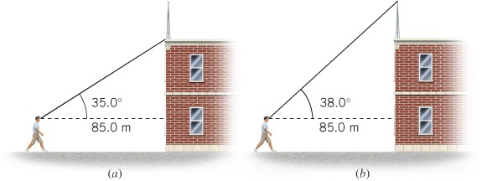
Solution for Problem 7
8. The drawing shows sodium and chloride ions positioned at the corners of a cube that is part of the crystal structure of sodium chloride (common table salt). The edges of the cube are each 0.281 nm (1 nm = 1 nanometer = 10⁻⁹ m) in length. What is the value of the angle θ in the drawing?
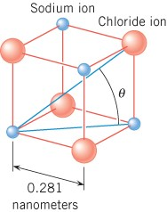
Solution for Problem 8
9. A person is standing at the edge of the water and looking out at the ocean (see the drawing). The height of the person’s eyes above the water is h = 1.6 m, and the radius of the earth is R = 6.38 x 10⁶ m. (a) How far is it to the horizon? In other words, what is the distance d from the person’s eyes to the horizon? (Note: At the horizon the angle between the line of sight and the radius of the earth is 90°.) (b) Express this distance in miles.
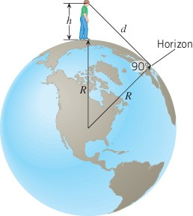
Solution for Problem 9
10. (a) Two workers are trying to move a heavy crate. One pushes on the crate with a force $\vec{A}$, which has a magnitude of 445 newtons and is directed due west. The other pushes with a force $\vec{B}$, which has a magnitude of 325 newtons and is directed due north. What are the magnitude and direction of the resultant force $\vec{A}+\vec{B}$ applied to the crate? (b) Suppose that the second worker applies a force $-\vec{B}$ instead of $\vec{B}$. What then are the magnitude and direction of the resultant force $\vec{A}-\vec{B}$ applied to the crate? In both cases express the direction relative to due west.
Solution for Problem 10
11. Consider the following four force vectors:
$\vec{F_{1}}=50.0$ newtons, due east
$\vec{F_{2}}=10.0$ newtons, due east
$\vec{F_{3}}=40.0$ newtons, due west
$\vec{F_{4}}=30.0$ newtons, due west
Which two vectors add together to give a resultant with the smallest magnitude, and which two vectors add to give a resultant with the largest magnitude? In each case specify the magnitude and direction of the resultant.
Solution for Problem 11
12. Vector $\vec{A}$ has a magnitude of 12.3 units and points due west. Vector $\vec{B}$ points due north. (a) What is the magnitude of $\vec{B}$ if $\vec{A}+\vec{B}$ has a magnitude of 15.0 units? (b) What is the direction of $\vec{A}+\vec{B}$ relative to due west? (c) What is the magnitude of $\vec{B}$ if $\vec{A}-\vec{B}$ has a magnitude of 15.0 units? (d) What is the direction of $\vec{A}-\vec{B}$ relative to due west?
Solution for Problem 12
13. Soccer player #1 is 8.6 m from the goal (see the drawing). If she kicks the ball directly into the net, the ball has a displacement labeled $\vec{A}$. If, on the other hand, she first kicks it to player #2, who then kicks it into the net, the ball undergoes two successive displacements, $\vec{A_{y}}$ and $\vec{A_{x}}$. What are the magnitudes and directions of $\vec{A_{x}}$ and $\vec{A_{y}}$?
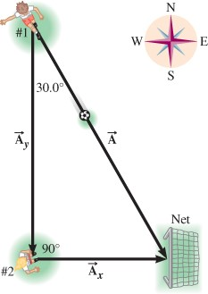
Solution for Problem 13
14. The three displacement vectors in the drawing have magnitudes of A = 5.00 m,
B = 5.00 m, and C = 4.00 m. Find the resultant (magnitude and directional angle) of the three vectors by means of the component method. Express the directional angle as an angle above the positive or negative x axis.
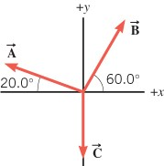
Solution for Problem 14
15. Displacement vector $\vec{A}$ points due east and has a magnitude of 2.00 km. Displacement vector $\vec{B}$ points due north and has a magnitude of 3.75 km. Displacement vector $\vec{C}$ points due west and has a magnitude of 2.50 km. Displacement vector $\vec{D}$ points due south and has a magnitude of 3.00 km. Find the magnitude and direction (relative to due west) of the resultant vector $\vec{A}+\vec{B}+\vec{C}+\vec{D}$.
Solution for Problem 15
16. Two geological field teams are working in a remote area. A global positioning system (GPS) tracker at their base camp shows the location of the first team as 38 km away, 19° north of west, and the second team as 29 km away, 35° east of north. When the first team uses its GPS to check the position of the second team, what does the GPS give for the second team’s (a) distance from them and (b) direction, measured from due east?
Solution for Problem 16
17. A chimpanzee sitting against his favorite tree gets up and walks 51 m due east and 39 m due south to reach a termite mound, where he eats lunch. (a) What is the shortest distance between the tree and the termite mound? (b) What angle does the shortest distance make with respect to due east?
Solution for Problem 17
18. The speed of an object and the direction in which it moves constitute a vector quantity known as the velocity. An ostrich is running at a speed of 17.0 m/s in a direction of 68.0° north of west. What is the magnitude of the ostrich’s velocity component that is directed (a) due north and (b) due west?
Solution for Problem 18
19. The volume of liquid flowing per second is called the volume flow rate Q and has the dimensions of [L]³/[T]. The flow rate of a liquid through a hypodermic needle during an injection can be estimated with the following equation:
The length and radius of the needle are L and R, respectively, both of which have the dimension [L]. The pressures at opposite ends of the needle are P₂ and P₁, both of which have the dimensions of [M]/{[L][T]²}. The symbol η represents the viscosity of the liquid and has the dimensions of [M]/{[L][T]}. The symbol π stands for pi and, like the number 8 and the exponent n, has no dimensions. Using dimensional analysis, determine the value of n in the expression for Q.
Solution for Problem 19
20. A pilot flies her route in two straight-line segments. The displacement vector $\vec{A}$ for the first segment has a magnitude of 244 km and a direction 30.0° north of east. The displacement vector $\vec{B}$ for the second segment has a magnitude of 175 km and a direction due west. The resultant displacement vector is $\vec{R}=\vec{A}+\vec{B}$ and makes an angle θ with the direction due east. Using the component method, find the magnitude of $\vec{R}$ and the directional angle θ.
Solution for Problem 20
21. What are the x and y components of the vector that must be added to the following three vectors, so that the sum of the four vectors is zero? Due east is the+x direction, and due north is the +y direction.
$\vec{A}=113$ units, 60.0° south of west
$\vec{B}=222$ units, 35.0° south of east
$\vec{C}=177$ units, 23.0° north of east
Solution for Problem 21
 | Dr. Donovan's Classes Page |  | Dr. Donovan's PH 201 Homework Page
 | NMU Physics Department Web Page |  | NMU Main Page

Please send any comments or questions about this page to ddonovan@nmu.edu
This page last updated on November 6, 2021

