PH 202 Homework Assignment Chapter on Magnetism &
B Field – 26 Problems Total
1. In New England, the horizontal component of the earth’s magnetic field has a magnitude of 1.6 x 10-5 T. An electron is shot vertically straight up from the ground with a speed of 2.1 x 106 m/s. What is the magnitude of the acceleration caused by the magnetic force? Ignore the gravitational force acting on the electron.
Solution for Problem 1
2. (a) A proton, traveling with a velocity of 4.5 x 106 m/s due east, experiences a magnetic force that has a maximum magnitude of 8.0 x 10-14 N and a direction of due south. What are the magnitude and direction of the magnetic field causing the force? (b) Repeat part (a) assuming the proton is replaced by an electron.
Solution for Problem 2
3. At a certain location, the horizontal component of the earth’s magnetic field is
2.5 x 10-5 T, due north. A proton moves eastward with just the right speed for the magnetic force on it to balance its weight. Find the speed of the proton.
Solution for Problem 3
4. When a charged particle moves at an angle of 25° with respect to a magnetic field, it experiences a magnetic force of magnitude F. At what angle (less than 90°) with respect to this field will this particle, moving at the same speed, experience a magnetic force of magnitude 2F?
Solution for Problem 4
5. A magnetic field has a magnitude of 1.2 x 10-3 T, and an electric field has a magnitude of 4.6 x 103 N/C. Both fields point in the same direction. A positive 1.8 µC charge moves at a speed of 3.1 x 106 m/s in a direction that is perpendicular to both fields. Determine the magnitude of the net force that acts on the charge.
Solution for Problem 5
6. The drawing shows a parallel plate capacitor that is moving with a speed of 32 m/s through a 3.6-T magnetic field. The velocity $\vec{v}$ is perpendicular to the magnetic field. The electric field within the capacitor has a value of 170 N/C, and each plate has an area of
7.5 x 10-4 m2. What is the magnetic force (magnitude and direction) exerted on the positive plate of the capacitor?
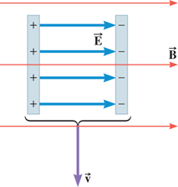
Solution for Problem 6
7. An ionized helium atom has a mass of 6.6 x 10-27 kg and a speed of 4.4 x 105 m/s. It moves perpendicular to a 0.75-T magnetic field on a circular path that has a 0.012-m radius. Determine whether the charge of the ionized atom is +e or +2e.
Solution for Problem 7
8. In the operating room, anesthesiologists use mass spectrometers to monitor the respiratory gases of patients undergoing surgery. One gas that is often monitored is the anesthetic isoflurane (molecular mass = 3.06 x 10-25 kg). In a spectrometer, a singly ionized molecule of isoflurane (charge = +e) moves at a speed of 7.2 x 103 m/s on a circular path that has a radius of 0.10 m. What is the magnitude of the magnetic field that the spectrometer uses?
9. A charged particle with a charge-to-mass ratio of Q/m = 5.7 x 108 C/kg travels on a circular path that is perpendicular to a magnetic field whose magnitude is 0.72 T. How much time does it take for the particle to complete one revolution?
Solution for Problem 9
10. A charged particle enters a uniform magnetic field and follows the circular path shown in the drawing. (a) Is the particle positively or negatively charged? Why? (b) The particle’s speed is 140 m/s, the magnitude of the magnetic field is 0.48 T, and the radius of the path is 960 m. Determine the mass of the particle, given that its charge has a magnitude of
8.2 x 10-4 C.
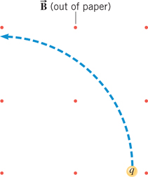
Solution for Problem 10
11. Suppose that an ion source in a mass spectrometer produces doubly ionized gold ions (Au2+), each with a mass of 3.27 x 10-25 kg. The ions are accelerated from rest through a potential difference of 1.00 kV. Then, a 0.500-T magnetic field causes the ions to follow a circular path. Determine the radius of the path.
Solution for Problem 11
12. A proton with a speed of 3.5 x 106 m/s is shot into a region between two plates that are separated by a distance of 0.23 m. As the drawing shows, a magnetic field exists between the plates, and it is perpendicular to the velocity of the proton. What must be the magnitude of the magnetic field so the proton just misses colliding with the opposite plate?
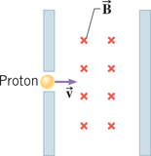
Solution for Problem 12
13. A charged particle moves through a velocity selector at a constant speed in a straight line. The electric field of the velocity selector is 3.80 x 103 N/C, while the magnetic field is 0.360 T. When the electric field is turned off, the charged particle travels on a circular path whose radius is 4.30 cm. Find the charge-to-mass ratio of the particle.
Solution for Problem 13
14. At New York City, the earth’s magnetic field has a vertical component of 5.2 x 10-5 T that points downward (perpendicular to the ground) and a horizontal component of 1.8 x 10-5 T that points toward geographic north (parallel to the ground). What are the magnitude and direction of the magnetic force on a 6.0-m long, straight wire that carries a current of 28 A perpendicularly into the ground?
Solution for Problem 14
15. A horizontal wire of length 0.53 m, carrying a current of 7.5 A, is placed in a uniform external magnetic field. When the wire is horizontal, it experiences no magnetic force. When the wire is tilted upward at an angle of 19°, it experiences a magnetic force of 4.4 x 10-3 N. Determine the magnitude of the external magnetic field.
Solution for Problem 15
16. A loop of wire has the shape of a right triangle (see the drawing) and carries a current of I = 4.70 A. A uniform magnetic field is directed parallel to side AB and has a magnitude of 1.80 T. (a) Find the magnitude and direction of the magnetic force exerted on each side of the triangle. (b) Determine the magnitude of the net force exerted on the triangle.
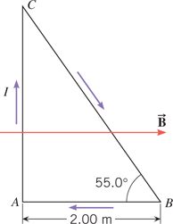
Solution for Problem 16
17. A horizontal wire is hung from the ceiling of a room by two massless strings. The wire has a length of 0.20 m and a mass of 0.080 kg. A uniform magnetic field of magnitude 0.070 T is directed from the ceiling to the floor. When a current of I = 42 A exists in the wire, the wire swings upward and, at equilibrium, makes an angle φ with respect to the vertical, as the drawing shows. Find (a) the angle φ and (b) the tension in each of the two strings.
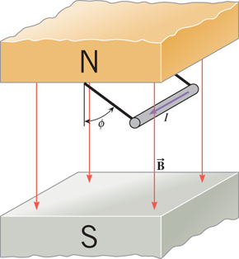
Solution for Problem 17
18. The two conducting rails in the drawing are tilted upward so they each make an angle of 30.0° with respect to the ground. The vertical magnetic field has a magnitude of 0.050 T. The 0.20-kg aluminum rod (length = 1.6 m) slides without friction down the rails at a constant velocity. How much current flows through the rod?
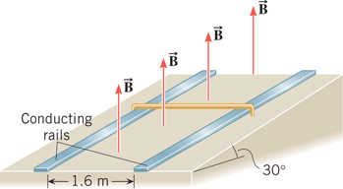
Solution for Problem 18
19. Two circular coils of current-carrying wire have the same magnetic moment. The first coil has a radius of 0.088 m, has 140 turns, and carries a current of 4.2 A. The second coil has 170 turns and carries a current of 9.5 A. What is the radius of the second coil?
Solution for Problem 19
20. The rectangular loop in the drawing consists of 75 turns and carries a current of
I = 4.4 A. A 1.8-T magnetic field is directed long the +y axis. The loop is free to rotate about the z axis. (a) Determine the magnitude of the net torque exerted on the loop and (b) state whether the 35° angle will increase or decrease.
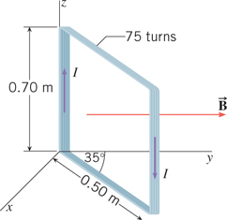
Solution for Problem 20
21. In the model of the hydrogen atom created by Niels Bohr, the electron moves around the proton at a speed of 2.2 x 106 m/s in a circle of radius 5.3 x 10-11 m. Considering the orbiting electron to be a small current loop, determine the magnetic moment associated with this motion.
(Hint: The electron travels around the circle in a time equal to the period of the motion.)
Solution for Problem 21
22. A long solenoid has a length of 0.65 m and contains 1400 turns of wire. There is a current of 4.7 A in the wire. What is the magnitude of the magnetic field within the solenoid?
Solution for Problem 22
23. The magnetic field produced by the solenoid in a magnetic resonance imaging (MRI) system designed for measurements on whole human bodies has a field strength of
7.0 T, and the current in the solenoid is 2.0 x 102 A. What is the number of turns per meter of length of the solenoid? Note that the solenoid used to produce the magnetic field in this type of system has a length that is not very long compared to its diameter. Because of this and other design considerations, your answer will be only an approximation.
Solution for Problem 23
24. Two long, straight wires are separated by 0.120 m. The wires carry currents of 8.0 A in opposite directions, as the drawing indicates. Find the magnitude of the net magnetic field at the points labeled (a) A and (b) B.
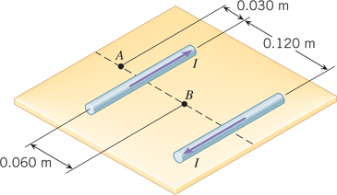
Solution for Problem 24
25. A piece of copper wire has a resistance per unit length of 5.90 x 10-3 Ω/m. The wire is wound into a thin, flat coil of many turns that has a radius of 0.140 m. The ends of the wire are connected to a 12.0-V battery. Find the magnetic field strength at the center of the coil.
Solution for Problem 25
26. The wire in the figure below carries a current of 12 A. Suppose that a second long, straight wire is placed right next to this wire. The current in the second wire is 28 A. Use Ampère’s law to find the magnitude of the magnetic field at a distance of r = 0.72 m from the wires when the currents are (a) in the same direction and (b) in opposite directions.
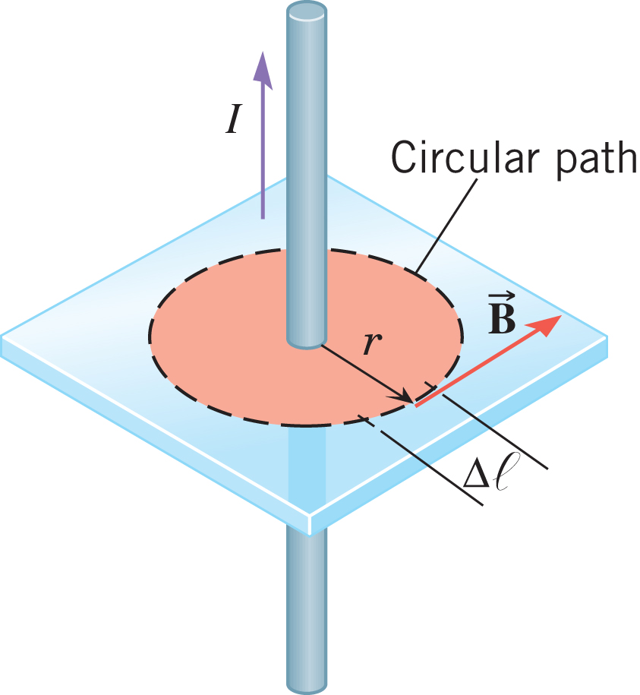
Solution for Problem 26
 | Dr. Donovan's Classes Page |  | Dr. Donovan's PH 202 Homework Page
 | NMU Physics Department Web Page |  | NMU Main Page

Please send any comments or questions about this page to ddonovan@nmu.edu
This page last updated on January 6, 2021

