PH 202 Homework Assignment Chapter on Optics Reflection – 17 Problems Total
1. You are trying to photograph a bird sitting on a tree branch, but a tall hedge is blocking your view. However, as the drawing shows, a plane mirror reflects light from the bird into your camera. For what distance must you set the focus of the camera lens in order to snap a sharp picture of the bird’s image?
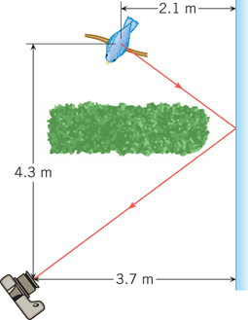
Solution for Problem 1
2. Two plane mirrors are separated by 120°, as the drawing illustrates. If a ray strikes mirror M1 at a 65° angle of incidence, at what angle θ does it leave mirror M2?
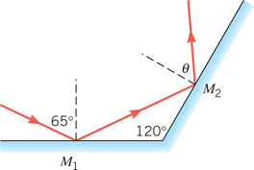
Solution for Problem 2
3. The drawing shows a laser beam shining on a plane mirror that is perpendicular to the floor. The beam’s angle of incidence is 33.0°. The beam emerges from the laser at a point that is 1.10 m from the mirror and 1.80 m above the floor. After reflection, how far from the base of the mirror does the beam strike the floor?
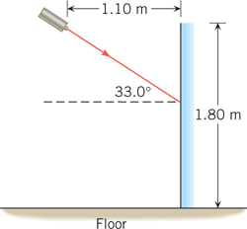
Solution for Problem 3
4. The drawing shows two plane mirrors that intersect at an angle of 50°. An incident light ray reflects from one mirror and then the other. What is the angle θ between the incident and outgoing rays?
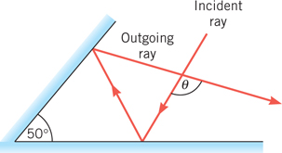
Solution for Problem 4
5. A 2.0-cm-high object is situated 15.0 cm in front of a concave mirror that has a radius of curvature of 10.0 cm. Using a ray diagram drawn to scale, measure (a) the location and (b) the height of the image. The mirror must be drawn to scale.
Solution for Problem 5
6. A convex mirror has a focal length of - 40.0 cm. A 12.0-cm-tall object is located
40.0 cm in front of this mirror. Using a ray diagram drawn to scale, determine the (a) location and (b) size of the image. Note that the mirror must be drawn to scale.
Solution for Problem 6
7. A small statue has a height of 3.5 cm and is placed in front of a concave mirror. The image of the statue is inverted, 1.5 cm tall, and located 13 cm in front of the mirror. Find the focal length of the mirror.
Solution for Problem 7
8. A mirror produces an image that is located 34.0 cm behind the mirror when the object is located 7.50 cm in front of the mirror. What is the focal length of the mirror, and is the mirror concave or convex?
Solution for Problem 8
9. The outside mirror on the passenger side of a car is convex and has a focal length of
- 7.0 m. Relative to this mirror, a truck traveling in the rear has an object distance of 11 m. Find (a) the image distance of the truck and (b) the magnification of the mirror.
Solution for Problem 9
10. When viewed in a spherical mirror, the image of a setting sun is a virtual image. The image lies 12.0 cm behind the mirror. (a) Is the mirror concave or convex? Why? (b) What is the radius of curvature of the mirror?
Solution for Problem 10
11. A concave mirror has a focal length of 12 cm. This mirror forms an image located 36 cm in front of the mirror. What is the magnification of the mirror?
Solution for Problem 11
12. A dentist’s mirror is placed 2.0 cm from a tooth. The enlarged image is located
5.6 cm behind the mirror. (a) What kind of mirror (plane, concave, or convex) is being used? (b) Determine the focal length of the mirror. (c) What is the magnification? (d) How is the image oriented relative to the object?
Solution for Problem 12
13. A concave makeup mirror is designed so the virtual image it produces is twice the size of the object when the distance between the object and the mirror is 14 cm. What is the radius of curvature of the mirror?
Solution for Problem 13
14. A concave mirror has a focal length of 30.0 cm. The distance between an object and its image is 45.0 cm. Find the object and image distances, assuming that (a) the object lies beyond the center of curvature and (b) the object lies between the focal point and the mirror.
Solution for Problem 14
15. A concave mirror has a focal length of 42 cm. The image formed by this mirror is 97 cm in front of the mirror. What is the object distance?
Solution for Problem 15
16. A person whose eyes are 1.70 m above the floor stands in front of a plane mirror. The top of her head is 0.12 m above her eyes. (a) What is the height of the shortest mirror in which she can see her entire image? (b) How far above the floor should the bottom edge of the mirror be placed?
Solution for Problem 16
17. A small postage stamp is placed in front of a concave mirror (radius = R) so that the image distance equals the object distance. (a) In terms of R, what is the object distance? (b) What is the magnification of the mirror? (c) State whether the image is upright or inverted relative to the object. Draw a ray diagram to guide your thinking.
Solution for Problem 17
 | Dr. Donovan's Classes Page |  | Dr. Donovan's PH 202 Homework Page
 | NMU Physics Department Web Page |  | NMU Main Page

Please send any comments or questions about this page to ddonovan@nmu.edu
This page last updated on January 6, 2021

