PH 202 Homework Assignment Chapter on Charge and
E Field – 31 Problems Total
1. Iron atoms have been detected in the sun’s outer atmosphere, some with many of their electrons stripped away. What is the net electric charge (in coulombs) of an iron atom with 26 protons and 7 electrons? Be sure to include the algebraic sign (+ or -) in your answer.
Solution for Problem 1
2. An object has a charge of -2.0 µC. How many electrons must be removed so that the charge becomes +3.0 µC?
Solution for Problem 2
3. Four identical metal spheres have charges of qA = -8.0 µC, qB = -2.0 µC, qC = +5.0 µC, and qD = +12.0 µC. (a) Two of the spheres are brought together so they touch, and then they are separated. Which spheres are they, if the final charge on each one is +5.0 µC? (b) In a similar manner, which three spheres are brought together and then separated, if the final charge on each of the three is +3.0 µC? (c) The final charge on each of the three separated spheres in part (b) is +3.0 µC. How many electrons would have to be added to one of these spheres to make it electrically neutral?
Solution for Problem 3
4. Water has a mass per mole of 18.0 g/mol, and each water molecule (H2O) has 10 electrons. (a) How many electrons are there in one liter (1.00 x 10-3 m3) of water? (b) What is the net charge of all these electrons?
Solution for Problem 4
5. In a vacuum, two particles have charges of q1 and q2, where q1 = +3.5 µC. They are separated by a distance of 0.26 m, and particle 1 experiences an attractive force of 3.4 N. What is q2 (magnitude and sign)?
Solution for Problem 5
6. Two tiny conducting spheres are identical and carry charges of -20.0 µC and +50.0 µC. They are separated by a distance of 2.50 cm. (a) What is the magnitude of the force that each sphere experiences, and is the force attractive or repulsive? (b) The spheres are brought into contact and then separated to a distance of 2.50 cm. Determine the magnitude of the force that each sphere now experiences, and state whether the force is attractive or repulsive.
Solution for Problem 6
7. Two charges attract each other with a force of 1.5 N. What will be the force if the distance between them is reduced to one-ninth of its original value?
Solution for Problem 7
8. Two point charges are fixed on the y axis: a negative point charge q1 = -25 µC at y1 = +0.22 m and a positive point charge q2 at y2 = +0.34 m. A third point charge q = +8.4 µC is fixed at the origin. The net electrostatic force exerted on the charge q by the other two charges has a magnitude of 27 N and points in the +y direction. Determine the magnitude of q2.
Solution for Problem 8
9. Two particles, with identical positive charges and a separation of 2.60 x 10-2 m, are released from rest. Immediately after the release, particle 1 has an acceleration $\vec{a_{1}}$ whose magnitude is , while particle 2 has an acceleration $\vec{a_{2}}$ whose magnitude is 8.50 x 103 m/s2. Particle 1 has a mass of 6.00 x 10-6 kg. Find (a) the charge on each particle and (b) the mass of particle 2.
Solution for Problem 9
10. A charge of -3.00 μC is fixed at the center of a compass. Two additional charges are fixed on the circle of the compass, which has a radius of 0.100 m. The charges on the circle are
-4.00 μC at the position due north and + 5.00 μC at the position due east. What are the magnitude and direction of the net electrostatic force acting on the charge at the center? Specify the direction relative to due east.
Solution for Problem 10
11. Suppose a single electron orbits about a nucleus containing two protons (+2e), as would be the case for a helium atom from which one of the two naturally occurring electrons is removed. The radius of the orbit is 2.65 x 10-11 m. Determine the magnitude of the electron’s centripetal acceleration.
Solution for Problem 11
12. The drawing shows three point charges fixed in place. The charge at the coordinate origin has a value of q1 = +8.00 µC; the other two charges have identical magnitudes, but opposite signs: q2 = -5.00 µC and q3 = +5.00 µC. (a) Determine the net force (magnitude and direction) exerted on q1 by the other two charges. (b) If q1 had a mass of 1.50 g and it were free to move, what would be its acceleration?
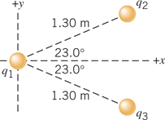
Solution for Problem 12
13. An electrically neutral model airplane is flying in a horizontal circle on a 3.0-m guideline, which is nearly parallel to the ground. The line breaks when the kinetic energy of the plane is 50.0 J. Reconsider the same situation, except that now there is a point charge of +q on the plane and a point charge of -q at the other end of the guideline. In this case, the line breaks when the kinetic energy of the plane is 51.8 J. Find the magnitude of the charges.
Solution for Problem 13
14. A single electron orbits a lithium nucleus that contains three protons (+3e). The radius of the orbit is 1.76 x 10-11 m. Determine the kinetic energy of the electron.
Solution for Problem 14
15. A small spherical insulator of mass 8.00 x 10-2 kg and charge +0.600 µC is hung by a thread of negligible mass. A charge of -0.900 µC is held 0.150 m away from the sphere and directly to the right of it, so the thread makes an angle θ with the vertical (see the drawing). Find (a) the angle θ and (b) the tension in the thread.
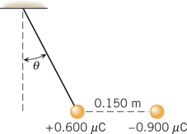
Solution for Problem 15
16. An electric field of 260 000 N/C points due west at a certain spot. What are the magnitude and direction of the force that acts on a charge of -7.0 µC at this spot?
Solution for Problem 16
17. The drawing shows two situations in which charges are placed on the x and y axes. They are all located at the same distance of 6.1 cm from the origin O. For each of the situations in the drawing, determine the magnitude of the net electric field at the origin.
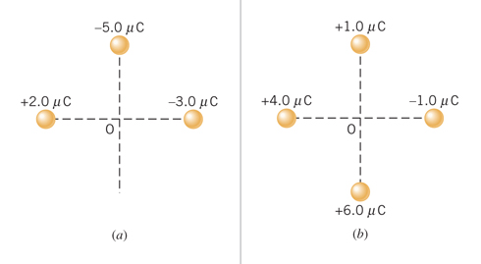
Solution for Problem 17
18. A uniform electric field exists everywhere in the x, y plane. This electric field has a magnitude of 4500 N/C and is directed in the positive x direction. A point charge -8.0 x 10-9 C is placed at the origin. Determine the magnitude of the net electric field at (a) x = -0.15 m, (b) x = +0.15 m, and (c) y = +0.15 m.
Solution for Problem 18
19. The membrane surrounding a living cell consists of an inner and an outer wall that are separated by a small space. Assume that the membrane acts like a parallel plate capacitor in which the effective charge density on the inner and outer walls has a magnitude of 7.1 x 10-6 C/m2. (a) What is the magnitude of the electric field within the cell membrane? (b) Find the magnitude of the electric force that would be exerted on a potassium ion (K+; charge = +e) placed inside the membrane.
Solution for Problem 19
20. A tiny ball (mass = 0.012 kg) carries a charge of -18 µC. What electric field (magnitude and direction) is needed to cause the ball to float above the ground?
Solution for Problem 20
21. A proton and an electron are moving due east in a constant electric field that also points due east. The electric field has a magnitude of 8.0 x 104 N/C. Determine the magnitude of the acceleration of the proton and the electron.
Solution for Problem 21
22. A particle of charge +12 µC and mass 3.8 x 10-5 kg is released from rest in a region where there is a constant electric field of +480 N/C. What is the displacement of the particle after a time of 1.6 x 10-2 s?
Solution for Problem 22
23. An electron is released from rest at the negative plate of a parallel plate capacitor. The charge per unit area on each plate is $σ$ = 1.8 x 10-7 C/m2, and the plate separation is 1.5 x 10-2 m. How fast is the electron moving just before it reaches the positive plate?
Solution for Problem 23
24. The drawing shows an electron entering the lower left side of a parallel plate capacitor and exiting at the upper right side. The initial speed of the electron is 7.00 x 106 m/s. The capacitor is 2.00 cm long, and its plates are separated by 0.150 cm. Assume that the electric field between the plates is uniform everywhere and find its magnitude.
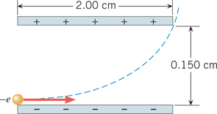
Solution for Problem 24
25. A small plastic ball with a mass of 6.50 x 10-3 kg and with a charge of +0.150 µC is suspended from an insulating thread and hangs between the plates of a capacitor (see the drawing). The ball is in equilibrium, with the thread making an angle of 30.0° with respect to the vertical. The area of each plate is 0.0150 m2. What is the magnitude of the charge on each plate?
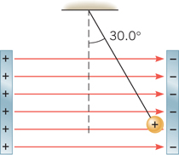
Solution for Problem 25
26. The drawing shows an edge-on view of two planar surfaces that intersect and are mutually perpendicular. Surface 1 has an area of 1.7 m2, while surface 2 has an area of
3.2 m2. The electric field $\vec{E}$ in the drawing is uniform and has a magnitude of 250 N/C. Find the magnitude of the electric flux through (a) surface 1 and (b) surface 2.
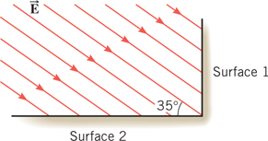
Solution for Problem 26
27. A surface completely surrounds a +2.0 x 10-6 C charge. Find the electric flux through this surface when the surface is (a) a sphere with a radius of 0.50 m, (b) a sphere with a radius of 0.25 m, and (c) a cube with edges that are 0.25 m long.
Solution for Problem 27
28. A solid nonconducting sphere has a positive charge q spread uniformly throughout its volume. The charge density or charge per unit volume, therefore, is . Use Gauss’ law to show that the electric field at a point within the sphere at a radius r has a magnitude of .
(Hint: For a Gaussian surface, use a sphere of radius r centered within the solid sphere of radius. Note that the net charge within any volume is the charge density times the volume.)
Solution for Problem 28
29. Two spherical shells have a common center. A -1.6 x 10-6 C charge is spread uniformly over the inner shell, which has a radius of 0.050 m. A +5.1 x 10-6 C charge is spread uniformly over the outer shell, which has a radius of 0.15 m. Find the magnitude and direction of the electric field at a distance (measured from the common center) of (a) 0.20 m, (b) 0.10 m, and (c) 0.025 m.
Solution for Problem 29
30. A long, thin, straight wire of length L has a positive charge Q distributed uniformly along it. Use Gauss’ law to show that the electric field created by this wire at a radial distance r has a magnitude of $E=\frac{λ}{2πε_{0}r}$, where $λ=\frac{Q}{L}$
(Hint: For a Gaussian surface, use a cylinder aligned with its axis along the wire and note that the cylinder has a flat surface at either end, as well as a curved surface.)
Solution for Problem 30
31. A small drop of water is suspended motionless in air by a uniform electric field that is directed upward and has a magnitude of 8480 N/C. The mass of the water drop is
3.50 x 10-9 kg. (a) Is the excess charge on the water drop positive or negative? Why? (b) How many excess electrons or protons reside on the drop?
Solution for Problem 31
 | Dr. Donovan's Classes Page |  | Dr. Donovan's PH 202 Homework Page
 | NMU Physics Department Web Page |  | NMU Main Page

Please send any comments or questions about this page to ddonovan@nmu.edu
This page last updated on January 5, 2021

