PH 220 Homework Assignment Chapter on One Dimensional Motion – 31 Problems Total
1. If you are driving $135. {km}/h \hat{\left(West\right)}$ along a straight path for a period of $3.50 s$, how far do you travel?
Solution for Problem 1
2. You are driving back from an event steadily at $95.0 {km}/h$ for $130. km$. It then begins to snow and you slow down to $45.0 {km}/h$. You arrive home after driving for $4.00 h and 47.0 min$.
(a) | How far from your home was the event?
(b) | What was your average speed on the drive home?

Solution for Problem 2
3. The position of an object is specified by the relationship
$$s=47-15t+3t^{2}$$
Where s is in meters when t is in seconds.
(a) | Plot s as a function of t from time $t=0 s$, to $t=4.0 s$, in steps of $0.1 s$.
(b) | Find the average speed of the object between time $t=0 s$, and $t=4.0 s$.
(c) | At what time between time $t=0 s$, and $t=4.0 s$.is the instantaneous speed zero?

Solution for Problem 3
4. A bus is moving with a speed of $75.0 {km}/h$. It is found to be $210. m$ behind a truck which is traveling at a speed of $58.0 {km}/h$. How long will it take the bus to reach the truck? Assume neither vehicle changes speed during this time
Solution for Problem 4
5. Information on an audio compact disc is encoded along an outward spiraling path that starts at radius $R_{inner}=2.34 cm$ and finishes at radius $R_{outer}=6.18 cm$. The distance between adjacent spiral windings is $1.7 x {10}^{-6} m$.
(a) | Determine the total length of the spiraling path. Hint: Imagine “unwinding” the spiral into a straight path with a width of $1.7 x {10}^{-6} m$ and note that the original spiral and the straight path occupy the same area.
(b) | To read the information, a CD player adjusts the rotation of the CD so that the player’s readout layer moves along the spiral at a constant speed of $1.25 m/s$. Estimate the maximum playing time of such a CD.

Solution for Problem 5
6. Determine the average speed and the average velocity for a round trip in which during the first portion of the trip involves traveling a distance of $340 km \left(\hat{West}\right)$ at a velocity of $120. {km}/h \left(\hat{West}\right)$. A lunch break of $2.25 h$ is taken. Then the return trip of course covers a distance of $340 km \left(\hat{East}\right)$ at a velocity of 95.5${km}/h \left(\hat{East}\right)$.
Solution for Problem 6
7. The position of a wheel rolling along a straight line is described by the equation:
$$\vec{s}=\left(4.30+8.76t-3.20t^{2}\right)\hat{\left(North\right)}$$
Where s is in units of meters when t is in units of seconds.
(a) | Determine the position of the wheel at times $1.00 s, 2.00 s, and 3.00 s$.
(b) | Determine the average velocity over the time interval $t=1.00 s$ to $t=3.00 s$.
(c) | Determine the instantaneous velocity at $t=1.00 s$ , $t=2.00 s$ , and $t=3.00 s$.

Solution for Problem 7
8. A bowling ball is rolling at a constant speed when it collides with the head pin of a set of bowling pins. The distance the ball traveled from leaving the hand of the bowler to the head pin is $17.3 m$. The bowler heard the sound of the ball hitting the pin $3.21 s$ after the ball left his hand. What is the speed of the rolling ball assuming the speed of sound in air is $340. m/s$?
Solution for Problem 8
9. A motorcycle accelerates from a speed of $74.0 {km}/h$ to a speed of $121. {km}/h$ . The acceleration is known to be $2.15 m/{s^{2}}$. How long does the motorcycle take to complete the speed up?
Solution for Problem 9
10. A truck moving in a straight line starts a point $s=0.00 m$ at a time $t=0.000 s$. It reaches the location $s=125.0 m$ with a speed of $v=43.00 m/s$ at time $t=15.00 s$. It later passes the point $s=496.0 m$ with a speed of $v=104. 0m/s$ at a time of $t=87.60 s$. Find:
(a) | The average speed between $t=15.00 s$ and $t=87.60 s$ and
(b) | The average acceleration between $t=15.00 s$ and $t=87.60 s$

Solution for Problem 10
11. A vehicle can accelerate approximately as shown in the velocity vs time plot shown below. The flat spots are the results of shifting gears. Each is $1.00 s$ in duration. When choosing the time for the start or end of a gear shift, use the middle. For example, the time between 1rst gear and 2nd gear can be considered $4.50 s$.
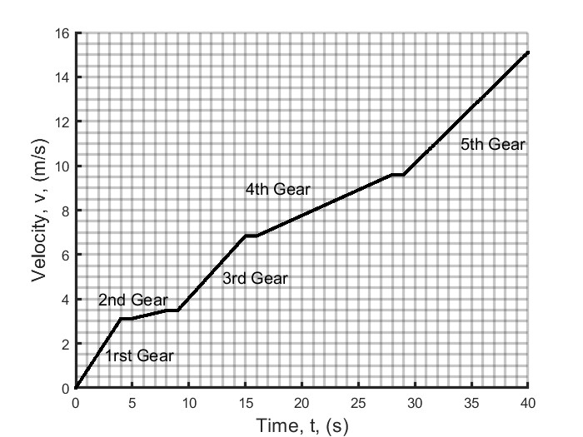
(a) | Estimate the average acceleration of the vehicle while it is in 2nd gear.
(b) | Estimate the average acceleration of the vehicle while it is in 4th gear.
(c) | Estimate the average acceleration of the vehicle between times $5.00 s and 35.0 s$.

Solution for Problem 11
12. A single point sized object moves along the z axis. Its location on that axis is described by:
$$z=\left(11.4 m/s\right)t-\left(2.23m/{s^{2}}\right)t^{2}$$
Where when t is in seconds, z will be in meters.
(a) | What is the velocity as a function of time?
(b) | What is the acceleration as a function of time?
(c) | Determine the location, velocity and acceleration of the object at time $t=2.40 s$?

Solution for Problem 12
13. The position of an object is given by:
$$S=At+Bt^{2}$$
Where S is in meters when t is in seconds.
(a) | What are the units of A and B?
(b) | What is the acceleration as a function of time?
(c) | What are the velocity and acceleration at time $t=4.10 s$.?
(d) | What is the velocity as a function of time if
 | $S=At+Bt^{-4}$?

Solution for Problem 13
14. A baseball pitcher pitches a baseball with an average speed of $43.0 m/s$. Assume the in making the pitch, the ball is displaced $3.85 m$ from a point behind his body to a point in front of the body where he releases the ball. Assume the ball started at rest. What is the average acceleration of the baseball during the pitch motion?
CC BY-SA 3.0, https://commons.wikimedia.org/w/index.php?curid=326267
Solution for Problem 14
15. Demonstrate that
$$\overline{v}=\frac{v_{0}+v}{2}$$
Is not valid when the acceleration is
$$a=A+Bt$$
Where A and B are constants.
Solution for Problem 15
16. A driver is not focusing on their driving as they approach a red light. When they are $30.0 m$ from the light, they are traveling at a speed of $20.0 m/s$. If it takes them a time of $0.250 s$ to react and to apply the brakes which result in a deceleration of $3.75 m/{s^{2}}$, will they be able to stop in time?
Solution for Problem 16
17. A state police officer measures a skid mark on a highway to be $185. m$ long. If she assumes the average deceleration was $3.56 m/{s^{2}}$ based on the manufacturer’s specifications for the particular vehicle which made the skid marks, what must have been the vehicle’s original speed before it began to slow down?
Solution for Problem 17
18. A stuntwoman is traveling at a speed of $134. {km}/{hr}$ when she strikes an airbag designed to bring her safely to rest. If she travels a distance of $2.08 m$ as she is brought to rest, what is the acceleration she undergoes coming to rest? How many ‘g’ is that?
Solution for Problem 18
19. A stealth fighter jet accelerates uniformly from a speed of $45.0 m/s$ at a time $t=0.00 s$ to a speed of $205. m/s$ at a time $t=10.0 s$. How far did the jet travel between the times
$t=3.00 s$ and $t=8.00 s$?
Solution for Problem 19
20. On the fictional planet of Arrakis in Frank Herbet’s Dune novels and stories, sandworms can be $400. m$ long. Assume one is at rest a distance of $350. m$ from you and the worm uniformly accelerates. When the mouth of the worm is even with you the speed of the worm is found to be $18.9 m/s$. Assuming the acceleration continues unchanged, what is the speed of the tail as the worm finishes passing by you?
Solution for Problem 20
21. A police car is traveling with a constant speed of $93.54 {km}/h$when it is passed by a speeding car which is traveling with a constant speed of $142.7{km}/h$. The police car decides to pull the speeding car over and exactly $1.350 s$ after the speeder has passed the police car, the police car applies a constant acceleration of $2.000 m/{s^{2}}$. How much time will it take for the police car to overtake the speeding car?
Solution for Problem 21
22. Margo and Susan are competing in a foot race. When Margo is a distance $d_{2}=25.0 m$ from the finish line, Margo’s speed is $v_{M0}=4.50 m/s$ and she is a distance $d_{1}=6.30 m$ behind Susan. At this same moment, Susan’s speed is $v_{S0}=5.90 m/s$. Susan believes she has won the race so she allows herself to decelerate at a rate of $a=-0.480 m/{s^{2}}$ until she finishes the race. What constant acceleration does Margo need for the rest of the race to finish in a tie (side by side) with Susan?
Solution for Problem 22
23. Paul throws a ball straight up in the air. It returns to him and he catches it $4.30 s$ after he threw it up.
(a) | What was the initial speed of the ball when it left his hand?
(b) | What was the greatest height above the release of the ball from his hand did the ball reach?

Solution for Problem 23
24. A hot air balloon is rising with a constant velocity of $6.23 m/s \left(\hat{Up}\right)$. When the balloon is at a height $87.3 m \left(\hat{Up}\right)$ a package is released from rest relative to the balloon and allowed to move on its own under the action of the Earth’s gravity.
(a) | What is the distance from the ground to box $0.670 s$ after the package left the balloon?
(b) | What is the velocity of the package $1.01 s$ after the package left the balloon?
(c) | How much time will it take for the package to reach the ground?

Solution for Problem 24
25. A model rocket weighs $m=2.76 kg$. Starting from rest the rocket rises straight up vertically with an acceleration of $a_{0}=4.65 m/{s^{2}}\left(\hat{Up}\right)$. When the rocket reaches a height of $h=1250. m \left(\hat{Up}\right)$, the engine runs out of fuel and only gravity acts on the rocket. We will be ignoring air resistance for this problem.
(a) | What is the velocity when the engine runs out of fuel?
(b) | How long does it take for the rocket to reach that height $\left(h=1250. m \left(\hat{Up}\right)\right)$ ?
(c) | What is the maximum height (H) that the rocket reaches before falling back to the ground?
(d) | How long does it take for the rocket to reach that maximum height (H)?
(e) | What is the final velocity of the rocket just before it hits the ground?
(f) | What was the total time the rocket was airborne?

Solution for Problem 25
26. Tanya notices several water balloons falling past her window on her fourth-floor apartment. The balloon strikes the sidewalk (hopefully missing pedestrians) $0.923 s$ after passing her window which is $20.0 m$ above the sidewalk. Assume each floor in the building occupies $5.00 m$ of height.
(a) | How fast are the balloons moving as they pass her window?
(b) | Determine which floor is dropping the balloons. Assume they are dropped from rest.

Solution for Problem 26
27. A large ballroom window is $3.45 m$ tall. An observant dancer notices a series of pebbles are falling past the window. The dancer determines that a pebble needs $0.165 s$ to cross the window. Assuming the pebble is released from rest, how far above the top of the window is the pebble when it is released and allowed to fall?
Solution for Problem 27
28. Determine the displacement an object undergoes from $t_{1}=2.40 s$ to $t_{2}=5.90 s$, if the object has its velocity described by the relationship:
$$v\left(t\right)=17.3 m/s+\left(21.2 m/{s^{2}}\right)t-\left(1.43 m/{s^{3}}\right)t^{2}$$
Solution for Problem 28
29. A particle has an acceleration described by $a\left(t\right)=At^{1/4}$ where $A=3.00 m/{s^{9/4}}$ At
$t=0 s, v=6.40 m/s, and S=0.00 m$.
(a) | What is the velocity as a function of time?
(b) | What is the displacement as a function of time?
(c) | What are the acceleration, velocity, and displacement at $t=4.00 s$

Solution for Problem 29
30. One can account for air resistance acting on a falling body by replacing acceleration with an approximation such as
$$a=\frac{dv}{dt}=g-kv$$
Where $k$ is a constant.
(a) | Using the boundary condition that $\left(v=0.00 m/s at t=0.00 s\right)$, find an expression for velocity as a function of time for the falling body.
 | Hint: consider a change of variables possibly using $U=g-kv$
(b) | Find an expression for the terminal velocity, which is the maximum value the velocity of the object can reach while falling.

Solution for Problem 30
31. Below is a figure of a position vs time plot for motion along a single line, so one-dimensional motion only. Answer the questions found after the plot.
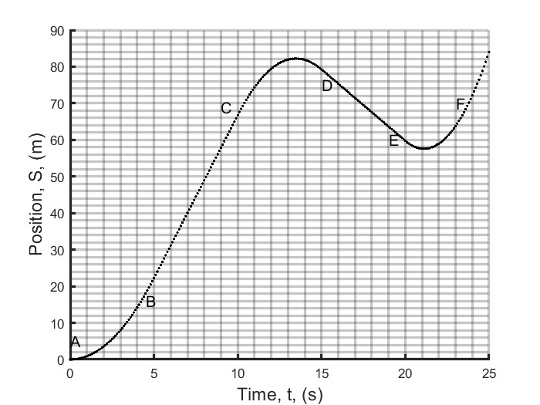
First, Consider the region between points A and B
(a) | Is the object moving in a positive or negative direction?
(b) | Is the object speeding up or slowing down?
(c) | Is the object accelerating or decelerating?

Next, Consider the region between points C and D
(d) | Is the object moving in a positive or negative direction?
(e) | Is the object speeding up or slowing down?
(f) | Is the object accelerating or decelerating?

Now, Consider the region between E and F
(g) | Is the object moving in a positive or negative direction?
(h) | Is the object speeding up or slowing down?
(i) | Is the object accelerating or decelerating?

This time, Consider the region between B and C
(j) | Is the object moving in a positive or negative direction?
(k) | Is the object speeding up or slowing down?
(l) | Is the object accelerating or decelerating?

Finally, Consider the region between D and E
(m) | Is the object moving in a positive or negative direction?
(n) | Is the object speeding up or slowing down?
(o) | Is the object accelerating or decelerating?

Solution for Problem 31
 | Dr. Donovan's Classes Page |  | Dr. Donovan's PH 220 Homework Page
 | NMU Physics Department Web Page |  | NMU Main Page

Please send any comments or questions about this page to ddonovan@nmu.edu
This page last updated on December 19, 2023

