Introduction to using MULTIsiM
A user manual for MULTIsiM created by National Instruments can be found here:
http://physics.nmu.edu/~ddonovan/software/MULTIsiM%20User%20Manual%20from%20NI.pdf
You are going to use MULTIsiM to create a few circuits and then provide screen captures and paste them into a WORD document for submission. The primary goal for this lab is to develop some basic familiarity and basic skills using the electronic circuit simulator software.
Exercise #1: Creating a basic series circuit
Produce a circuit similar to the one shown below. In place of the values I used for the power supply and resistors use your class seat number (see the seating chart) to get it if you are unclear. I used a value of 9 since that number is not in use by any of you.
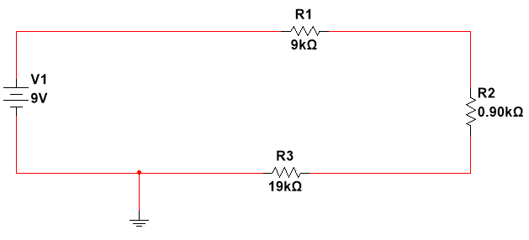
Exercise #2: Adding Multimeters and making basic measurements.
Add an ammeter, and four voltmeters as shown below. Your screen capture should include the measured values as shown. Of course your measurements will be different as your component values are different.
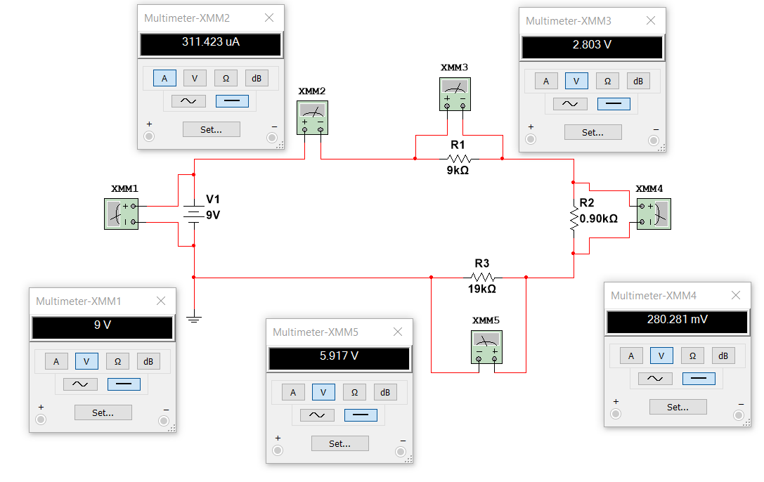
Exercise #3: Creating a basic parallel circuit
Produce a circuit similar to the one shown below. In place of the values I used for the power supply and resistors use your class seat number (see the seating chart) to get it if you are unclear. I used a value of 9 since that number is not in use by any of you.
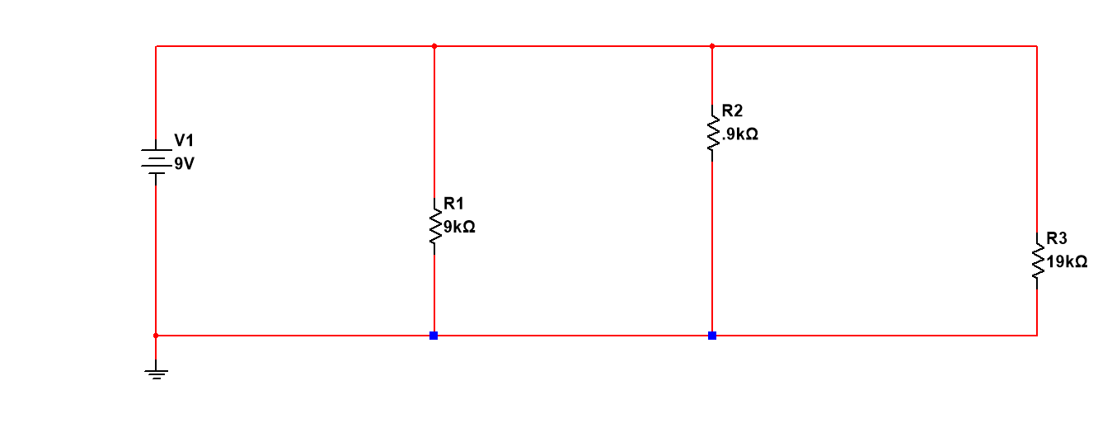
Exercise #4: Adding Multimeters and making basic measurements.
Add an voltmeter, and four ammeters as shown below. Your screen capture should include the measured values as shown. Of course your measurements will be different as your component values are different.
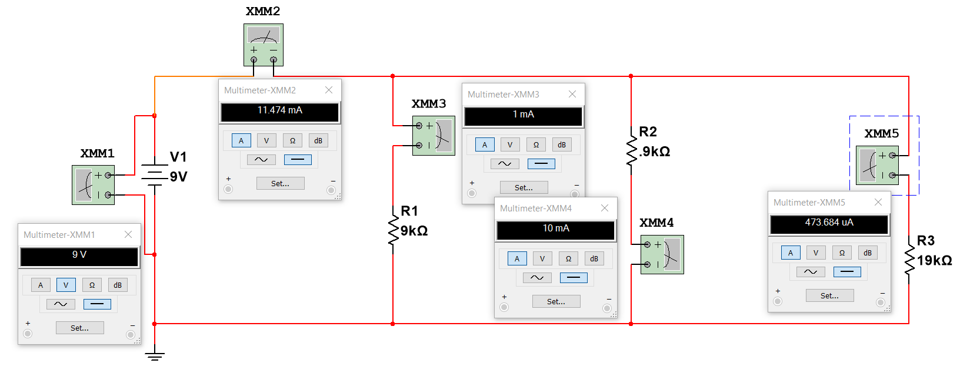
Exercise #5: Creating a basic RC circuit
Produce a circuit similar to the one shown below. In place of the values I used for the power supply and resistors use your class seat number (see the seating chart) to get it if you are unclear. I used a value of 9 since that number is not in use by any of you.
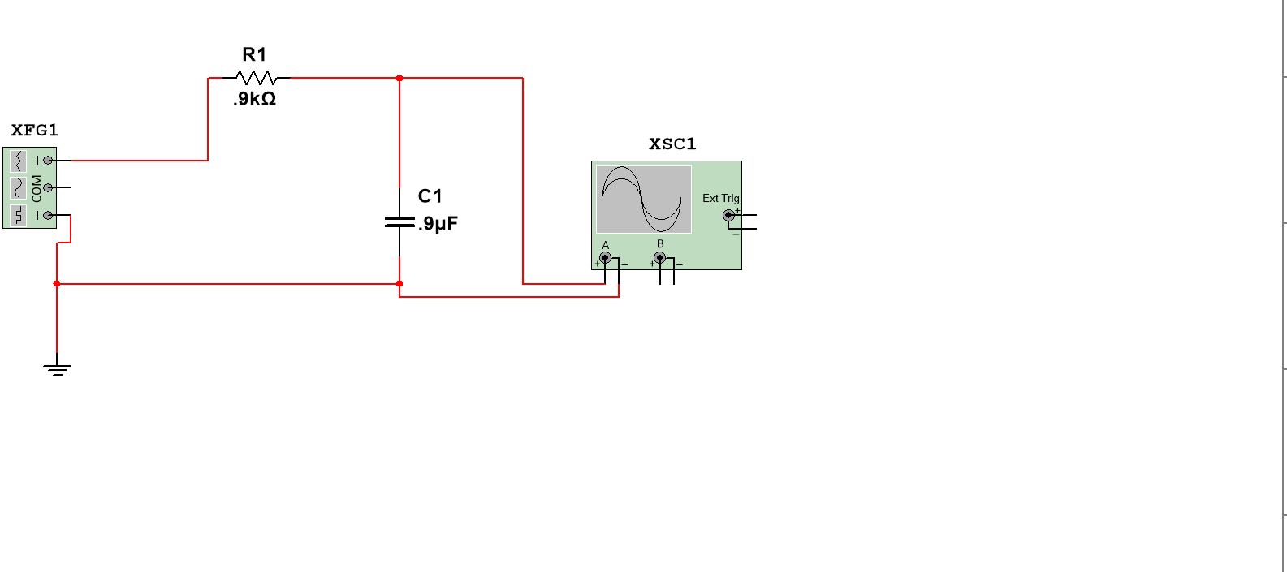
Exercise #6: Adding Instrument Displays and making basic measurements.
Tap on the frequency generator and make sure you select square wave and tap on the oscilloscope to open it. Here is what you should see.
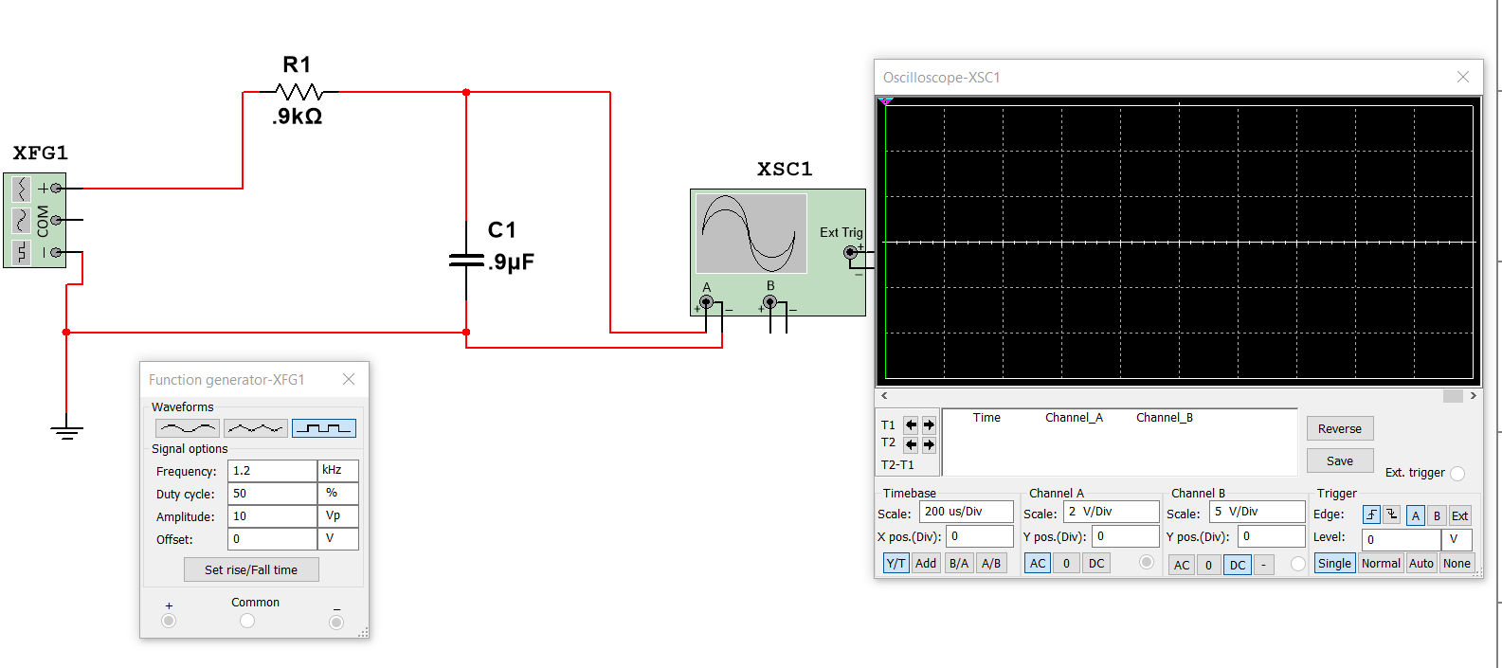
For my values of $0.90 kΩ$ and $0.90 μF$, I am using the function generator settings of
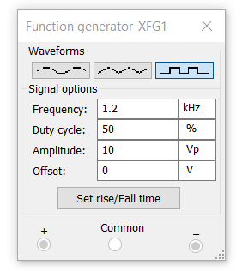
The Oscilloscope settings look like
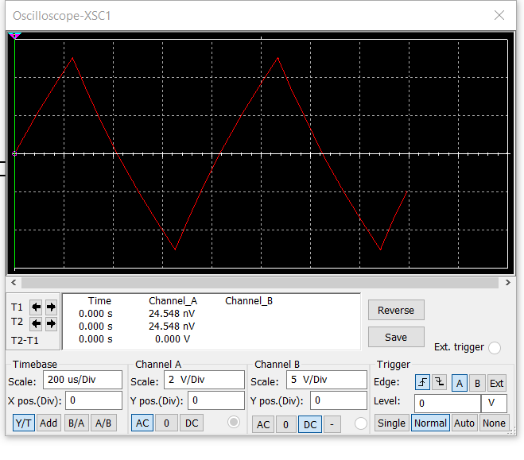
Now you will need to adjust the frequency generator to your values of R and F. For values of $0.10 kΩ$ and $0.10 μF$, I found the function generator settings below gave good results. For the other values in between adjust in between and you should get a similar Oscilloscope pattern.
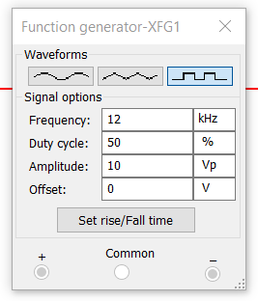
The corresponding Oscilloscope settings are
