PH 320 | Introduction to Operational Amplifiers | Name

1. Construct a voltage follower or buffer circuit.
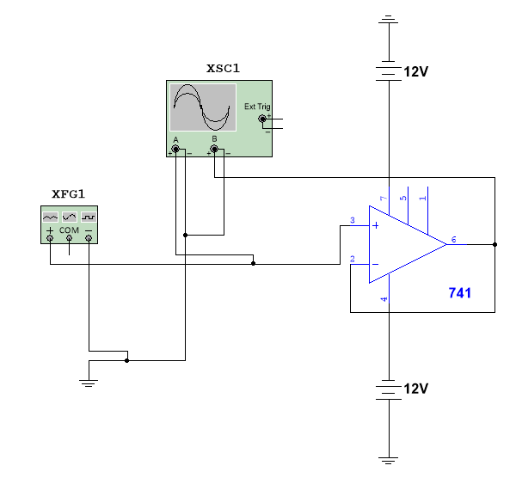
a) Use the sine wave generator to provide V_{in}. Determine at what voltage you saturate the op-amp. Use the peak to peak voltages as your measure of voltages. This is of the Input Voltage not, the Output Voltage!
b) Using a voltage that is one-half the saturation voltage, determine the gain of this circuit experimentally. Gain_{exp} = V_{out}/V_{in}
Gain

c) Determine the phase relationship (angle between 0 and 360˚) between the input and output signals.
Phase

2. Construct the following inverting amplifier circuit
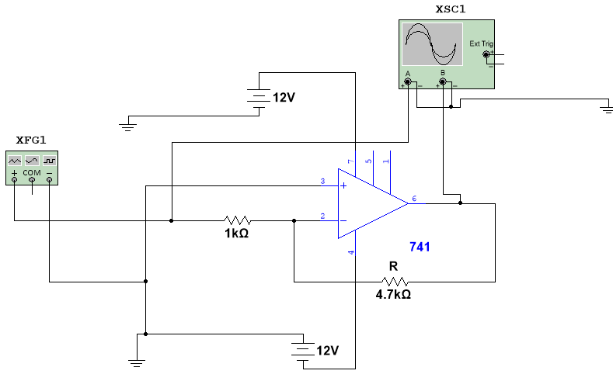
a) Use R = 4700 Ω. Continue to use ± V as ± 12 V. Determine the saturation voltage again using a sine wave and still using peak to peak voltage.
V_{in} saturate

b) Using a voltage that is one-half the saturation voltage, determine the gain of this circuit experimentally.
Gain--Exp

c) Determine the phase relationship between the input and output signals.
Phase

d) Measure the voltages at the Non-inverting (+) and inverting (-) inputs of the op-amp. Remember to use AC voltage settings on the multimeter.
Voltage at +

Voltage at -

e) Derive the analytical expression for the theoretical gain of this circuit.
Gain--Theory

f) Now complete the following table by replacing R with the listed resistance and experimentally determining the gain. Then calculate the theoretical gain for this circuit for each R value. Finally calculate the percentage difference between the two values of gain.
R ( Ω ) | Gain - Experiment | Gain - Theory | % difference
1000
2200
5600
10,000

NOTE: It will most likely be necessary for you to decrease your input voltage to correctly measure the gain for some of these values. IF your output voltage equals your saturation voltage, you have saturated the op-amp and cannot use that voltage to calculate gain.
3. Construct the following non-inverting amplifier.
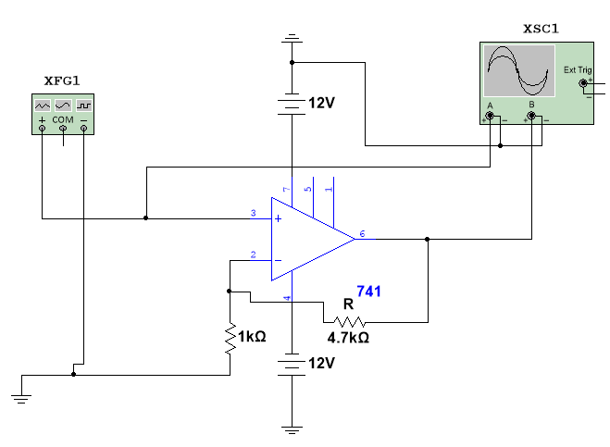
a) Use R = 4700 Ω. Continue to use ± V as ± 12 V. Determine the saturation voltage again using a sine wave.
V_{in} saturate

b) Using a voltage that is one-half the saturation voltage, determine the gain of this circuit experimentally.
Gain--Exp

c) Determine the phase relationship between the input and output signals.
Phase

d) Measure the voltages at the Non-inverting (+) and inverting (-) inputs of the op-amp. Remember to use AC voltage settings on the multimeter.
Voltage at +

Voltage at -

e) Derive the analytical expression for the theoretical gain of this circuit.
Gain--Theory

f) Now complete the following table by replacing R with the listed resistance and experimentally determining the gain. Then calculate the theoretical gain for this circuit for each R value. Finally calculate the percentage difference between the two values of gain.
R ( Ω ) | Gain - Experiment | Gain - Theory | % difference
1000
2200
5600
10,000

NOTE: It will most likely be necessary for you to decrease your input voltage to correctly measure the gain for some of these values. IF your output voltage equals your saturation voltage, you have saturated the op-amp and cannot use that voltage to calculate gain.
4. Construct the following difference amplifier. Note:d implies duplicate as MULTISim will not allow two objects to use same label.
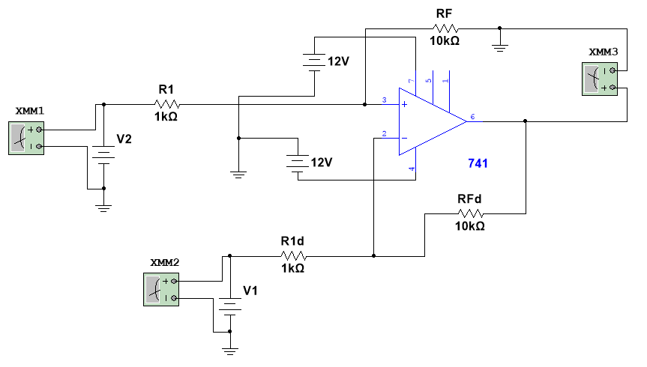
Create a pair of circuits to produce voltages for both this and the next exercise (actually, you will need three for the next one) Any variable resistor will work for this, 1KΩ, 10KΩ, etc.:
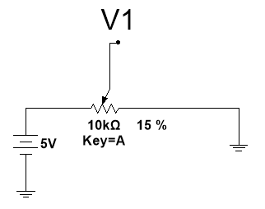
Theory for Vout is found from: $V_{out}=\frac{R_{F}}{R_{1}}\left(V_{2}-V_{1}\right)$
Derive this result here: (add pages if necessary)
For R1 use 1 kΩ and for RF use 10 kΩ. Use the multimeter to set the voltages from the power supplies. Be sure that the ground of the all supplies is the ground of your circuit. Complete the following table:
Approximate V2-V1 | V1 | V2 | Actual  V2-V1 | Vout | Theory Vout | %diff
+1
-1
+0.5
-0.5
+0.25
-0.25
0.0
 |  |  |  |  | Average

5. Construct the following voltage adder:
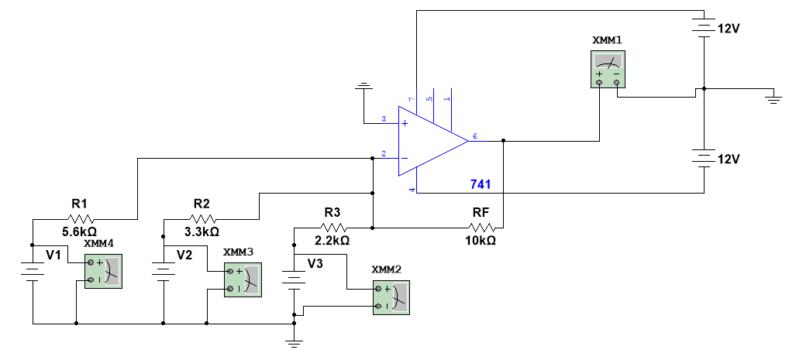
Theory says the following equation should hold:
$$V_{out}=-R_{F}\left(\frac{V_{1}}{R_{1}}+\frac{V_{2}}{R_{2}}+\frac{V_{3}}{R_{3}}\right)$$
Derive that result:
For RF use 10 kΩ for R1 use 5.6 k Ω, for R2 use 3.3 kΩ and for R3 use 2.2 kΩ. Use the multimeter to set the voltages from the power supplies. Be sure that the ground of the all supplies is the ground of your circuit. Choose sets of 3 voltages (V1, V2, and V3) and find Vout. Keep all input voltages under 1.0 V and for each combination cycle through once. For example if your first combination is (0.75V, 0.5V, 0.25V), let your second and third combinations be (0.25V, 0.75V, 0.5V) and (0.5V, 0.25V, 0.75V).
Complete the following table:
V1 | V2 | V3 | Vout | Vout-Theory | %diff
 |  |  |  | Average

