PH 320 | More Operational Amplifiers | Name

1. Construct the Comparator below:
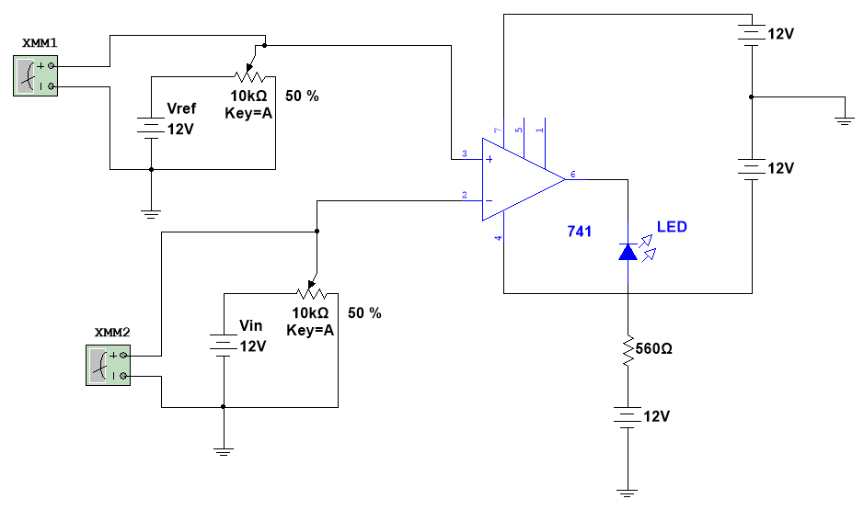
Use ± 12 V to power the op-amp. Set Vref to about 6 volts. Complete the table, getting approximately the values for Vin asked for.
V_{ref} (exact)

Vin (approx) (V) | Vin (exact) (V) | Vout (V) | LED on?
1
3
6
8
10

Describe purpose of this circuit:
2. Construct the following Integrator (Low Pass filter).
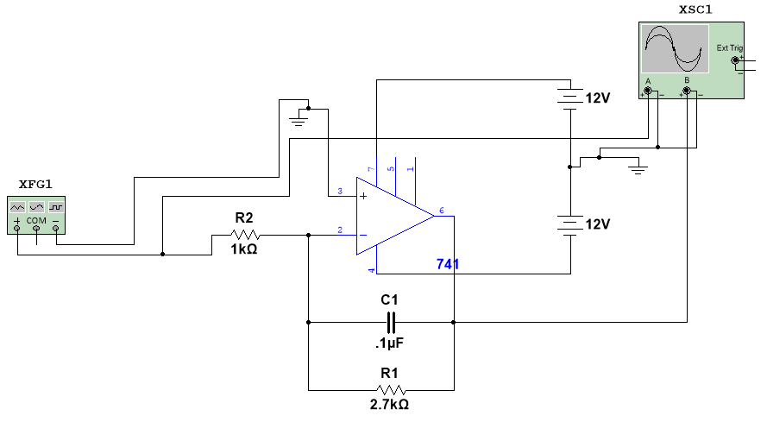
Use ± 12 V to power the op-amp. Use values R1 = 2.7 kΩ, R2 = 1.0 kΩ, and C1 = 0.1μF
Construct dB plots for this filter circuit. Use the sine wave function and measure both V_{in} and V_{out} for each frequency. Measure at approximately 0.25, 0.50, 0.75, and 1.0 for the ranges: 100, 1K, 10K, 100K, and 1M. Then use MATLAB to construct a dB plot by plotting dB on the vertical and log ω on the horizontal. Recall: ω=2πf and dB is found from:
$$dB=20 log⁡\left(\frac{V_{out}}{V_{in}}\right)$$
Note: in MATLAB a base 10 log is gotten using the function log10 not log. In MATLAB, log is ln or natural log.
At the point where the flat line changes slope you have the cut-off frequency. Determine this frequency.
$$ω_{Cut-off Experimental}$$

Theoretically:
$$ω_{Cut-off}=\frac{1}{R_{1}C_{1}}$$
$$ω_{Cut-off Theoretical}$$

Use your dB plot to choose a frequency in the middle of the integration range. First use a sine wave. The integral of a sine wave is of course a cosine wave. Using the scope to look at both V_{in} and V_{out} again simultaneously, verify that you do get a cosine wave out. Now try the other two wave forms from the signal generator. Record your output in the table below.
Input Wave | Output Wave | Integrate?
Sine Wave | Cosine Wave
Triangle Wave
Square Wave

Under the column Integrate, put yes or no.
3. Construct the following Differentiator (High Pass filter).
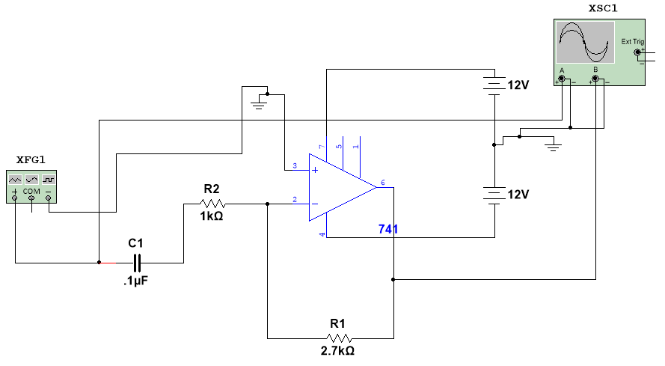
Use ± 12 V to power the op-amp. Use values R1 = 2.7 kΩ, R2 = 1.0 kΩ, and C2 = 0.1μF
Construct dB plots for this filter circuit. Use the sine wave function and measure both V_{in} and V_{out} for each frequency. Measure at approximately 0.25, 0.50, 0.75, and 1.0 for the ranges: 100, 1K, 10K, 100K, and 1M. Then use MATLAB to construct a dB plot by plotting dB on the vertical and log ω on the horizontal. Recall: ω=2πf and dB is found from:
$$dB=20 log⁡\left(\frac{V_{out}}{V_{in}}\right)$$
Note: in MATLAB a base 10 log is gotten using the function log10 not log. In MATLAB, log is ln or natural log.
At the point where the flat line changes slope you have the cut-off frequency. Determine this frequency.
$$ω_{Cut-off Experimental}$$

Theoretically:
$$ω_{Cut-off}=\frac{1}{R_{2}C_{2}}$$
$$ω_{Cut-off Theoretical}$$

Use your dB plot to choose a frequency in the middle of the differential range. First use a sine wave. The derivative of a sine wave is of course a cosine wave. Using the scope to look at both V_{in} and V_{out} again simultaneously, verify that you do get a cosine wave out. Now try the other two wave forms from the signal generator. Record your output in the table below.
Input Wave | Output Wave | Differentiate?
Sine Wave | Cosine Wave
Triangle Wave
Square Wave

Under the column Differentiate, put yes or no.
4. Construct the following Instrumentation amplifier.
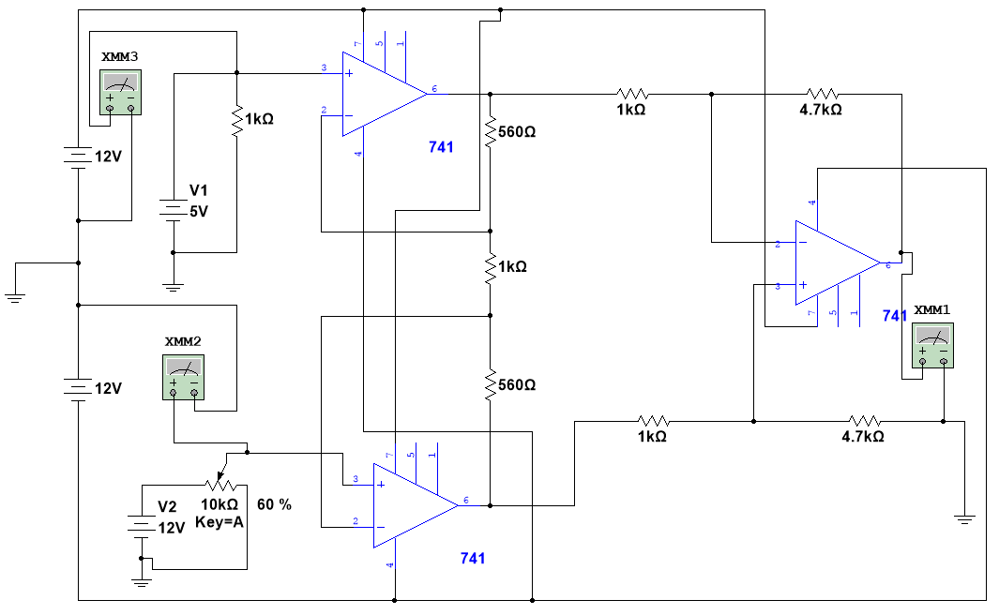
Adjust the 10 K potentiometer till Vout = 0. Measure the voltages at V1 and V2.
$$V_{1}=$$ |  |  | $$V_{2}=$$

Now adjust the 10 K potentiometer to find 3 different V2's. Be sure you do not saturate the output. Complete the following table.
V1 (V) | V2 (V) | V2-V1 (V) | V out (V) | Experimental  Gain
 |  |  | Average

Calculate theoretical gain for this circuit. Include additional pages to show work! Provide both an expression and a numerical value.
Gain--Theory

Gain--Theory

Calculate % difference in gain. Use an average experimental gain
% - Difference

