PH 320 | Thevenin Equivalent Circuits Lab | Name

Circuit 1:
Construct the following circuit
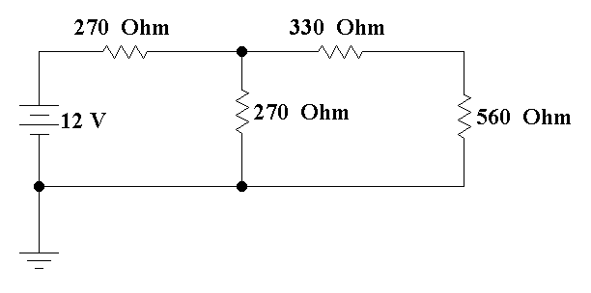
Complete the following table:
Voltage Across 560 Ω  (V) | Current Through 560 Ω (mA) | Power Dissipated by 560 Ω  (mW) | Current Supplied by Voltage Source  (mA) | Power Supplied by Voltage Source  (mW)

Now work out below the Thevenin equivalent circuit for the circuit above using the 560Ω resistor as your load.
$$V_{OC}=$$ |  |  | $$R_{TH}=$$

So our Thevenin equivalent circuit is :
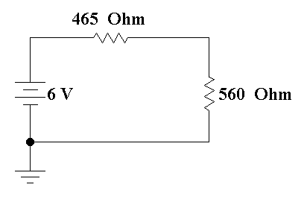
465 Ω is not a standard resistor so we will need to make a substitution.
Construct the following circuit:
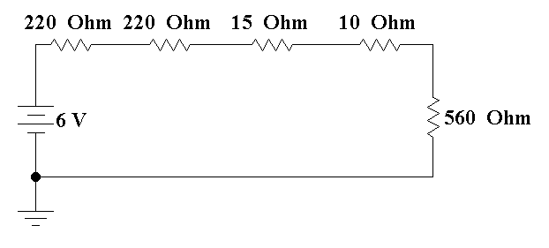
Complete the tables below:
Voltage Across 560 Ω  (V) | Current Through 560 Ω (mA) | Power Dissipated by 560 Ω  (mW) | Current Supplied by Voltage Source  (mA) | Power Supplied by Voltage Source  (mW)

% Difference Voltage Across 560 Ω  (V) | % Difference Current Through 560 Ω (mA) | % Difference Power Dissipated by 560 Ω  (mW) | % Difference Current Supplied by Voltage Source  (mA) | % Difference Power Supplied by Voltage Source  (mW)

For the % difference use the formula
$$\% difference= \frac{Original-Equivalent }{Original}x100\%$$
Circuit 2:
Construct the following circuit:
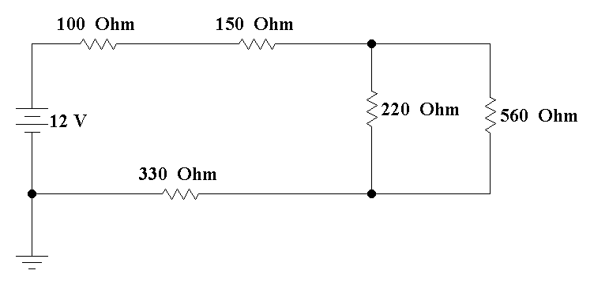
Complete the following table:
Voltage Across 560 Ω  (V) | Current Through 560 Ω (mA) | Power Dissipated by 560 Ω  (mW) | Current Supplied by Voltage Source  (mA) | Power Supplied by Voltage Source  (mW)

Now work out below the Thevenin equivalent circuit for the circuit above using the 560Ω resistor as your load.
$$V_{OC}=$$ |  |  | $$R_{TH}=$$

So our Thevenin equivalent circuit is :
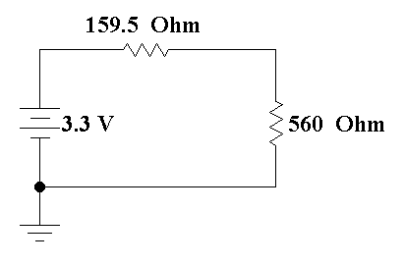
159.5 Ω is not a standard resistor so we will need to make a substitution.
Construct the following circuit:
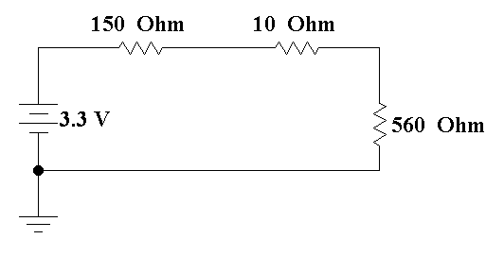 | 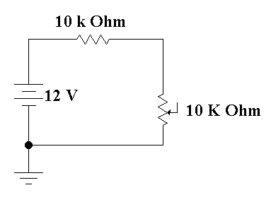

160 Ω is about as close to 159.5 Ω as we are going to get. Remember that resistors are 10% probably anyway.
If the power Supply cannot produce 3.30 V construct the circuit on the right, which will allow you to tap off 3.3 V between the center of the potentiometer and the ground.
Complete the tables below:
Voltage Across 560 Ω  (V) | Current Through 560 Ω (mA) | Power Dissipated by 560 Ω  (mW) | Current Supplied by Voltage Source  (mA) | Power Supplied by Voltage Source  (mW)

% Difference Voltage Across 560 Ω  (V) | % Difference Current Through 560 Ω (mA) | % Difference Power Dissipated by 560 Ω  (mW) | % Difference Current Supplied by Voltage Source  (mA) | % Difference Power Supplied by Voltage Source  (mW)

For the % difference use the formula provided before.
Circuit 3:
Construct the following circuit:
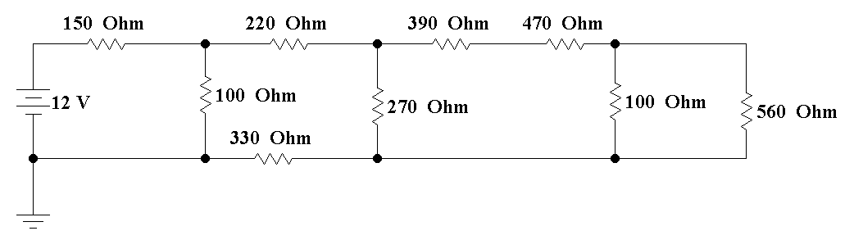
Complete the following table:
Voltage Across 560 Ω  (mV) | Current Through 560 Ω (µA) | Power Dissipated by 560 Ω  (µW) | Current Supplied by Voltage Source  (mA) | Power Supplied by Voltage Source  (mW)

Now work out below the Thevenin equivalent circuit for the circuit above using the 560Ω resistor as your load.
$$V_{OC}=$$ |  |  | $$R_{TH}=$$

So our Thevenin equivalent circuit is :
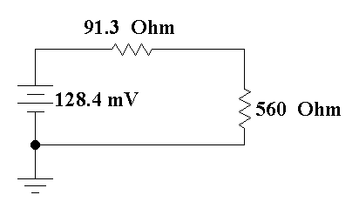
91.3 Ω is not a standard resistor so we will need to make a substitution. Moreover, 128.4 mV cannot be gotten from a standard power supply, so you will need to make the circuit on the right to get that low a voltage
Construct the following pair of circuits:
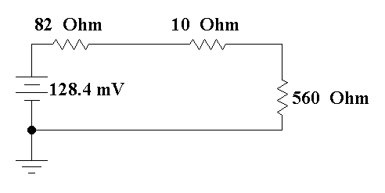 | 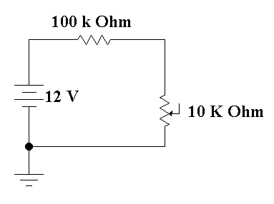

Complete the tables below:
Voltage Across 560 Ω  (mV) | Current Through 560 Ω (µA) | Power Dissipated by 560 Ω  (µW) | Current Supplied by Voltage Source  (µA) | Power Supplied by Voltage Source  (µW)

% Difference Voltage Across 560 Ω  (mV) | % Difference Current Through 560 Ω (µA) | % Difference Power Dissipated by 560 Ω  (µW) | % Difference Current Supplied by Voltage Source  (mA) | % Difference Power Supplied by Voltage Source  (mW)

For the % difference use the formula provided before.
Circuit 4 (The Moseler Special):
Construct the following circuit:
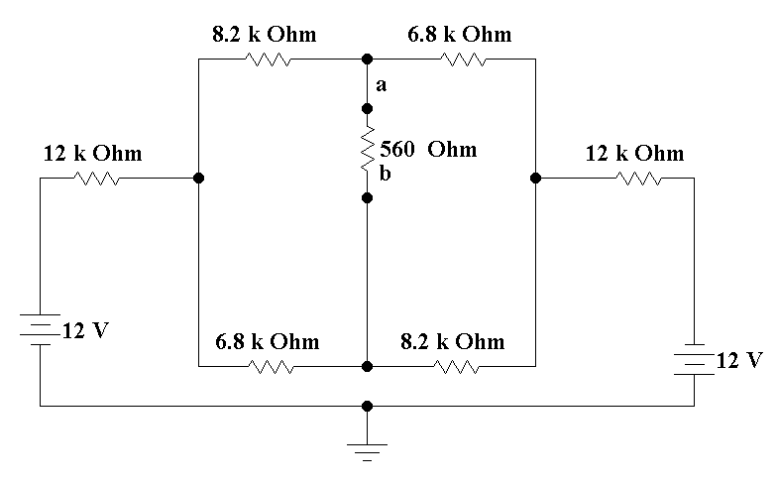
Complete the following table:
Voltage Across 560 Ω  (mV) | Current Through 560 Ω (µA) | Power Dissipated by 560 Ω  (µW) | Current Supplied by both Voltage Source  (µA) | Power Supplied by both Voltage Source  (mW)

Now work out below the Thevenin equivalent circuit for the circuit above using the 560Ω resistor as your load.
R_{EQ} is found from deactivating the source which leaves the following circuit:
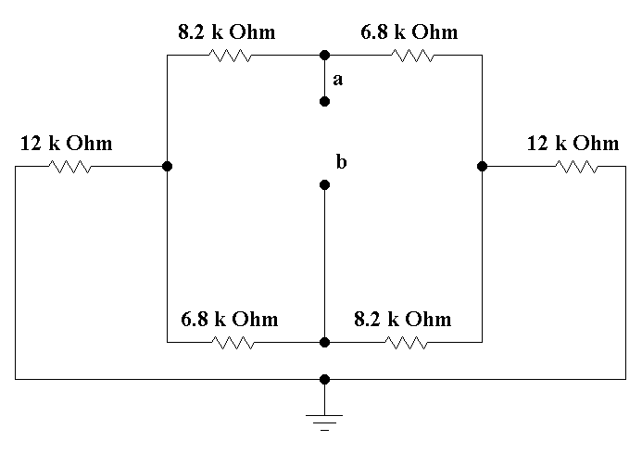
You can do some rearranging, but you will discover that you cannot simplify the resistance between (a) and (b) down from combining resistors in parallel and series. To solve the effective resistance, we need to put a generic voltage supply between (a) and (b). We then need to determine the current flowing between (a) and (b) and R_{EQ} is found from Ohm’s Law.
$$R_{EQ}=\frac{V_{ab}}{i_{ab}}$$
So we now have the following circuit:
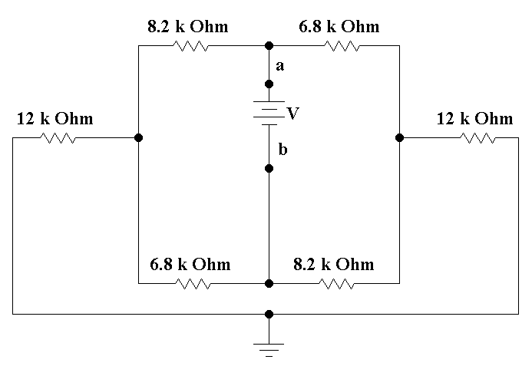
Write out mesh currents. I1 is the left side of the center pair of loops, i2 is the right side of the center pair of loops, and i3 is the bottom loop below the center pair. The equations become:
To find the open circuit Voltage we have the following circuit:
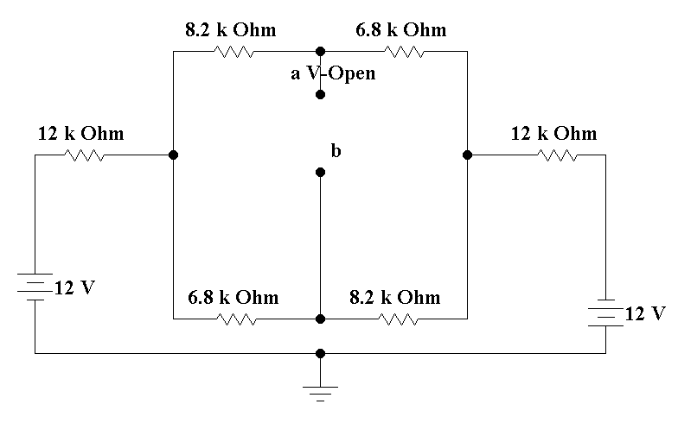
First, we need to find the two currents in the two mesh loops, the center one and the lower one. Let us call the center one i1 and the lower one i2. Then we need to do voltage walks to get the voltage difference between (a) and (b). So the mesh equations are:
$$V_{OC}=$$ |  |  | $$R_{TH}=$$

So our Thevenin equivalent circuit is :
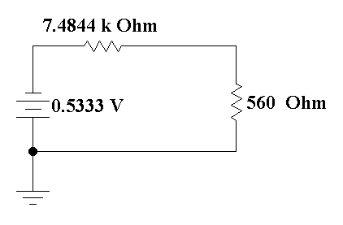
Once again, we need to use the variable power supply circuit and we need to combine resistors to approximate the Thevenin resistance. Construct the following two circuits
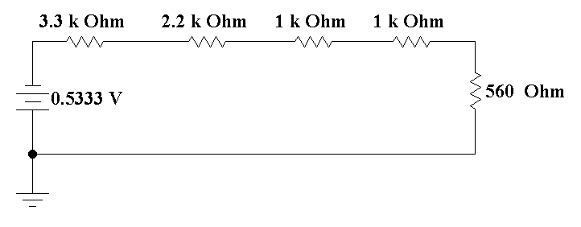

Complete the tables below:
Voltage Across 560 Ω  (mV) | Current Through 560 Ω (µA) | Power Dissipated by 560 Ω  (µW) | Current Supplied by Voltage Source  (µA) | Power Supplied by Voltage Source  (µW)

% Difference Voltage Across 560 Ω  (mV) | % Difference Current Through 560 Ω (µA) | % Difference Power Dissipated by 560 Ω  (µW) | % Difference Current Supplied by Voltage Source  (µA) | % Difference Power Supplied by Voltage Source  (mW)

For the % difference use the formula provided before.

