**Ph201 Momentum Lab Data**

**Experiment 1.** Car 1 collides with stationary car 2 which is stationary and loaded with block 2 and they bounces off each in an Elastic Collision.

Car 1 = 518.8 g, Car 2 = 503.1 g, Block 2 = 502.6g Flag width = 2.00 cm

Time A1 = .0162 s, Time A2 = .125 s, Time B1 = .0270s

**Before collision**  **After collision**

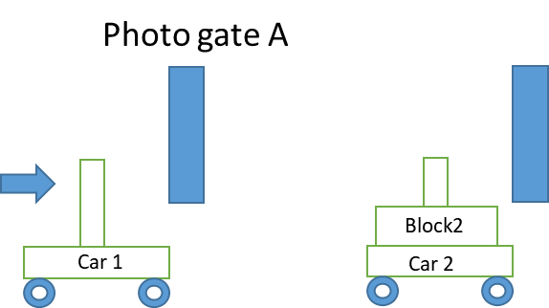 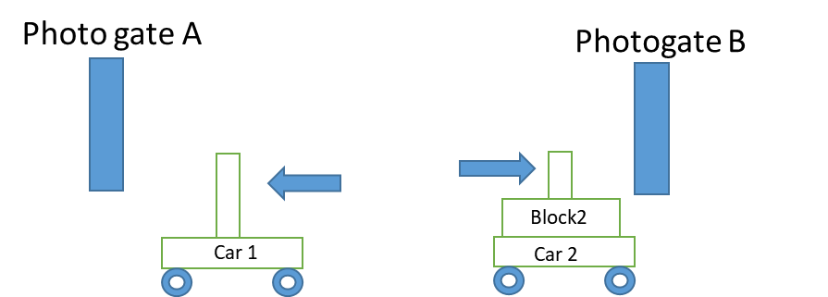

**Experiment 2.** Car 1 collides with stationary car 2 loaded with block 2 and sticks to car 2 in an inelastic collision and they both move through photogate B together.

Car 1 = 518.8 g, Car 2 = 503.1 g, Block 2 = 502.6g Flag width = 2.00 cm

Time A1 = .0227 s, Time B1 = .0687s

**Before collision After collision**

Photo gate B Photo gate B

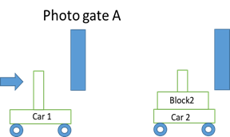 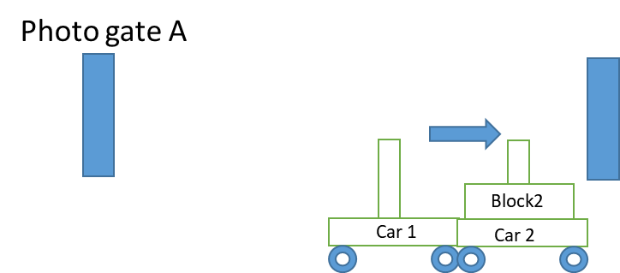

**Experiment 3** Cars flying apart. Both cars start with zero velocity then are given a force that causes them to move in opposite directions.

Car 1 = 518.8 g, Block 1 = 497.5 g Car 2 = 503.1 g, Block 2 = 502.6g Flag width = 2.00 cm

**Trial 1:** Both cars empty

Time A1 = .0460 s, Time B1 = .0430 s

**Trial 2:** Car 1 loaded with block 1 and Car 2 empty

Time A1 = .0650 s, Time B1 = .0320 s

**Trial 3:** Car 1 empty and Car 2 loaded with block 2

Time A1 = .0350 s, Time B1 = .0730 s

**Trial 3 illustration**

**Before**  **After**

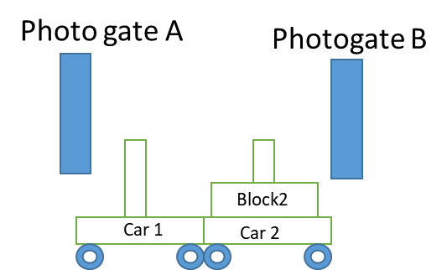 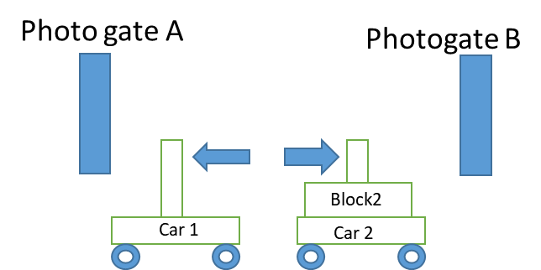

**Trial 4:** Car 1 loaded with block 1 and Car 2 loaded with block 2

Time A1 = .0520 s, Time B1 = .0510 s

**Experiment 4** Both cars are launched toward each other and bounce off in an elastic collision.

Car 1 = 518.8 g, Car 2 = 503.1 g, Block 2 = 502.6g Flag width = 2.00 cm

**Trial 1:** Both cars are unloaded.

**Before collision After collision**

Time A1 = .0320 s, Time B1 = .0320 s Time A2 = .0450 s, Time B2 = .0490 s

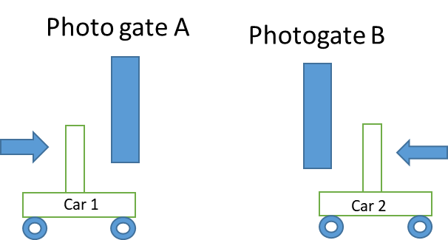 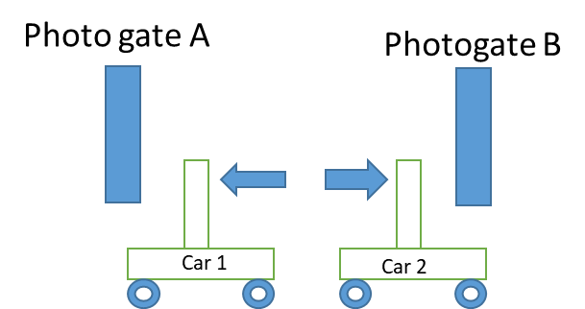

**Trial 2:** Car 1 is unloaded and Car 2 is loaded with Block 2

**Before collision After collision**

Time A1 = .0170 s, Time B1 = .0440 s Time A2 = .0310 s, Time B2 = .0440 s