Impulse momentum lab Data

Cart mass = 518.7 g

Trial 1 Magnet:

Vi = .272 m/s vf = .216 m/s

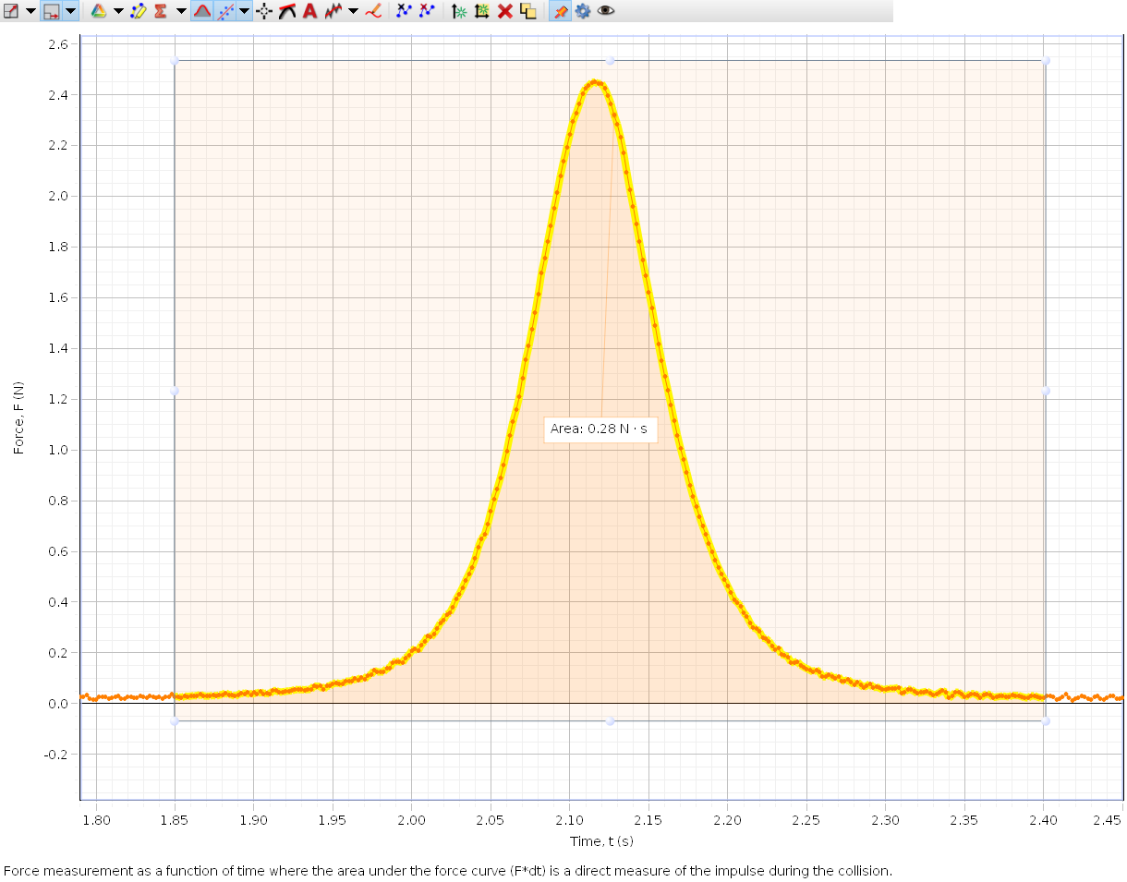

Trial 2 Weak spring:

Vi = .657m/s Vf = .601m/s

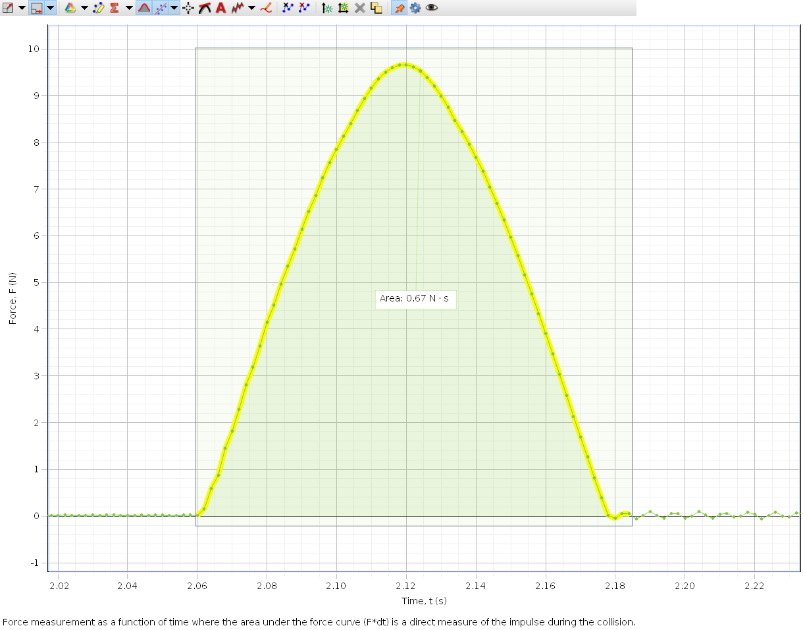

Trial 3 Stiff spring:

Vi = .393 m/s Vf = .314 m/s

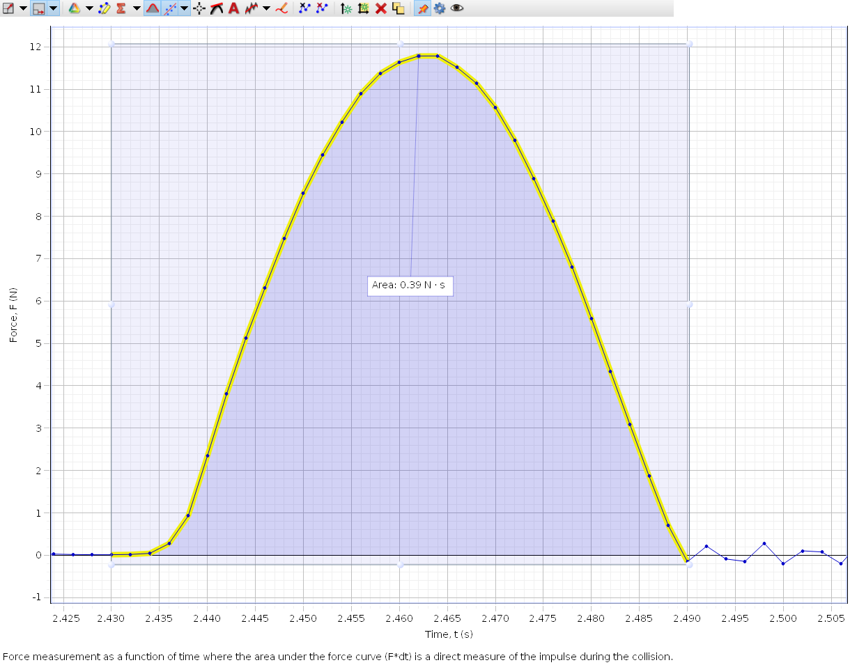

Trial 4 Rubber:

Vi = .478 m/s Vf = .168 m/s

