PH 201 Post-Lab 01 | Graphing | Name

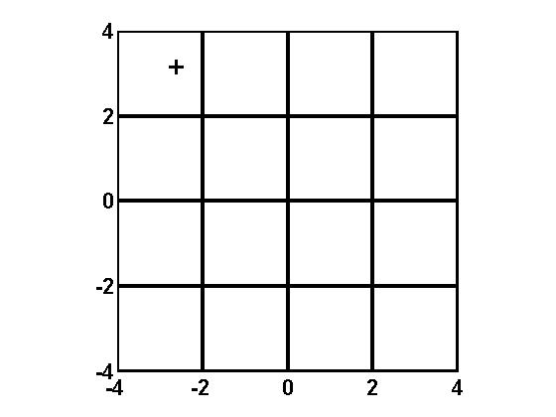 | 1. What are the coordinates of the ‘+’ plotted in the graph figure shown on the left?  (_______, ________)  2. Plot a dot at the location (1.75, -2.25). Make the dot fairly small and then circle it to make it easier to find.

3. You have a set of experimental data that you have plotted distance on the y axis and time squared on the x axis. You have drawn a “best straight line” and from this line you select two points,
(8.85 s², 1.92 m) and (1.04 s², 11.37 m). What is the slope of your line?
Slope =

A particular experimental relationship can be expressed mathematically by the equation
$$y=5.0 x^{-2.4}$$
4. If you created a ln(y) vs ln(x) plot (ln(y) is along the vertical axis), what would you find the slope to be?
Slope =

5. What would you find the y-intercept to be?
y-intercept =

